

#### Instituto Politécnico de Viana do Castelo





#### Graduation in Informatics Engineering

#### System Integration Course Unit

**Geographic Information Viewer with Interoperability and Information Systems Integration**

**António José Ribeiro Marques, nº21674**

**Nelson Filipe Faria Campinho, nº21751**

#### 2020 - 2021

#### Coordinator: Prof. Doutor Jorge Ribeiro | jribeiro@estg.ipvc.pt

Index

2. Technologies, tools, libraries, methodology and project management 4

2.1 Programming Environment 4

2.2 Technologies and Architecture 4

2.3.1 HTML 5

2.3.2 Javascript 5

2.3.3 CSS 6

2.3.4 Visual Studio Code 6

2.3.5 Postman 6

2.3.6 PostgreSQL 7

2.3.7 GeoServer 7

2.3.8 Leaflet 7

2.3.9 Apache Tomcat 8

3. Practical Case/Project Developed 9

3.1 Tutorial 12 9

3.1.1 Installation of WebSIG ​​support servers - PostGreSQL database 9

4.1.2 Import of Shapefiles to the PostgreSQL Database (with the geographic component postGIS) 14

4.1.3 View the information in the QuantumGIS viewer (Optional implementation) 17

4.1.4 Installation of the Geoserver Mapping Server 22

4.1.5 Connect the Geoserver with geographic data from the database and create WFS and WMS services 23

4.1.6 Visualization of Geographic Information via WebMaps (OpenLayers and Leaflet) - Information / Basic Tutorials 30

4.2 Final Project 31

Postgres 31

Geoserver 31

WebSIG Viewer 33

Database connection (php) 42

5. Conclusions 47

6. Bibliography and Web References 48

6.1 Web References: 48

Introduction and objectives

This project was developed associated with the curricular unit of System Integration of the 3rd year of the Graduation Degree in Informatics’ Engineering (Computer Science) at the School of Technology and Management of the Polytechnique institute of Viana do Castelo.

The **main objective** of this project is the development of a web portal with integration / interoperability of information and geographic information systems using standards, web services, geographic databases and map servers.

The **scope of this project** is a development of a web platform at IPVC and was proposed by Professor Jorge Ribeiro.

We build a webpage who contains a Leaflet map with layers from geoserver with 3763 Native SRS. Leaflet map allows you to add points, lines, and polygnos that are later inserted into the PostgreSQL database with PostGIS component that enables geometry component.

In order to make this project, our **methodology** was to practice with the tutorials provided by professor and search for related information in GitHub projects that use similar technologies and on YouTube.

**In the following report** is possible to find an introduction to this project, the explanation of the project architecture. After that, we have the section which has a description of the main technologies, tools, and libraries used.

# 2. Technologies, tools, libraries, methodology and project management

## 2.1 Programming Environment

Javascript, Php is the languages used for the development of each component of website development from client-side/server-side to database handling.

## 2.2 Technologies and Architecture

The architecture of the project is composed by a set of frameworks and technologies represented below.

### 2.3.1 HTML



Hypertext Markup Language (HTML) is the standard markup language for documents designed to be displayed in a web browser. It can be assisted by technologies such as Cascading Style Sheets (CSS) and scripting languages such as JavaScript.

### 2.3.2 Javascript



Javascript (JS) is a **scripting language**, primarily used on the Web. It is used to enhance HTML pages and is commonly found embedded in HTML code. JavaScript is an interpreted language. Thus, it **does not** need to be compiled. JavaScript renders web pages in an interactive and dynamic fashion. This allowing the pages to react to events, exhibit special effects, accept variable text, validate data, create cookies, detect a user’s browser**.**

### 2.3.3 CSS



CSS stands for Cascading Style Sheets with an emphasis placed on Style. CSS is a language used to describe reusable styles for presenting documents written in a markup language.

### 2.3.4 Visual Studio Code



Visual Studio Code is a souce code editor that, by default, supports JavaScript, TypeScript and Node.js but has extensions for other languages (Microsoft, 2020).

### Php icon - Free download on Iconfinder2.3.5 Postman

This scripting language is server oriented and can be embedded into HTML and thus is possible to apply it to the client-side. With this language can be created server that return information to clients’ requests (Group, 2020).

### 2.3.6 PostgreSQL



PostgreSQL is a powerful, open-source object-relational database system. It has more than 15 years of active development and a proven architecture that has earned it a strong reputation for reliability, data integrity, and correctness. PostgreSQL runs on all major operating systems, including Linux, UNIX and Windows.

### 2.3.7 GeoServer



GeoServer implements industry standard OGC protocols such as Web Feature Service (WFS), Web Map Service (WMS), and Web Coverage Service (WCS). Additional formats and publication options are available as extensions including Web Processing Service (WPS), and Web Map Tile Service (WMTS).

### 2.3.8 Leaflet



Leaflet is the leading open-source JavaScript library for mobile-friendly interactive maps. Leaflet is designed with simplicity. It works efficiently across all major desktop and mobile platforms, can be extended with lots of plugins.

### 2.3.9 Apache Tomcat



Apache Tomcat is an open-source Web server tool developed by the Apache Software Foundation (ASF). It is one of many Apache-related open-source products used by IT professionals for various tasks and objectives.

Apache Tomcat allows the implementation of Java Servlets and Java Server Pages (JSP) to promote an effective Java server environment. Users can also access resources for configuration and use extensible markup language (XML) to configure projects.

# 3. Practical Case/Project Developed

## 3.1 Tutorial 12

### 3.1.1 Installation of WebSIG ​​support servers - PostGreSQL database

This chapter is dedicated to the installation of PostgreSQL and enabling PostGIS.

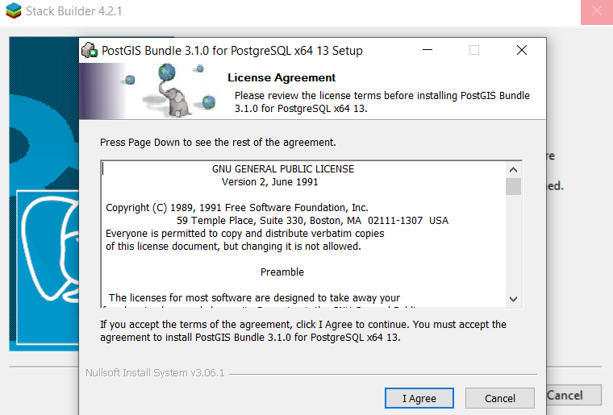

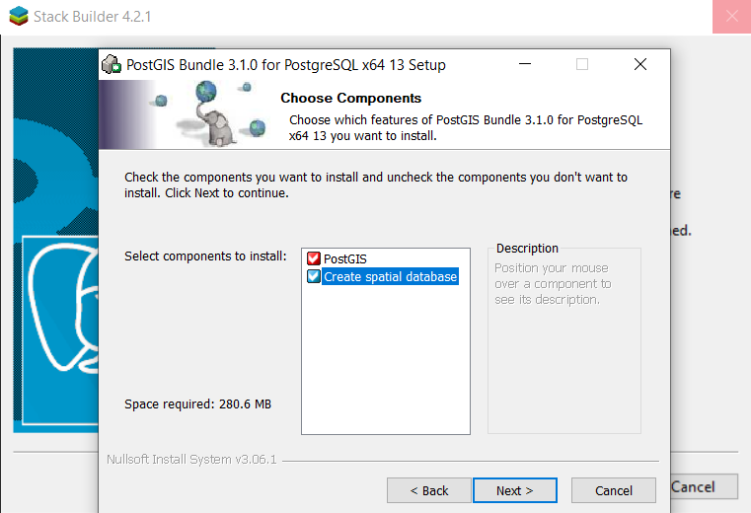

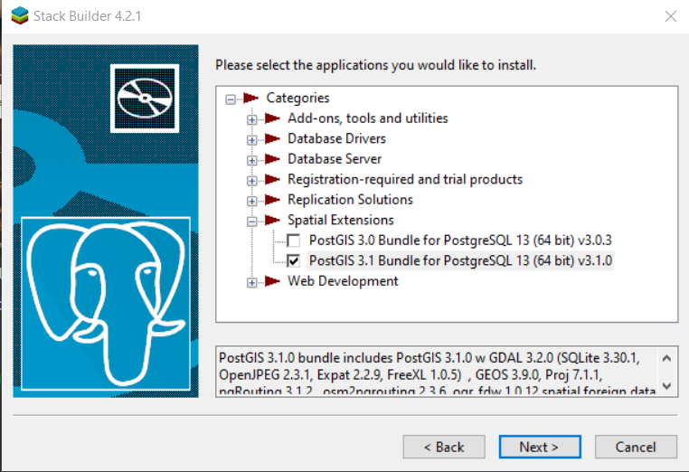

Activating installed PostGIS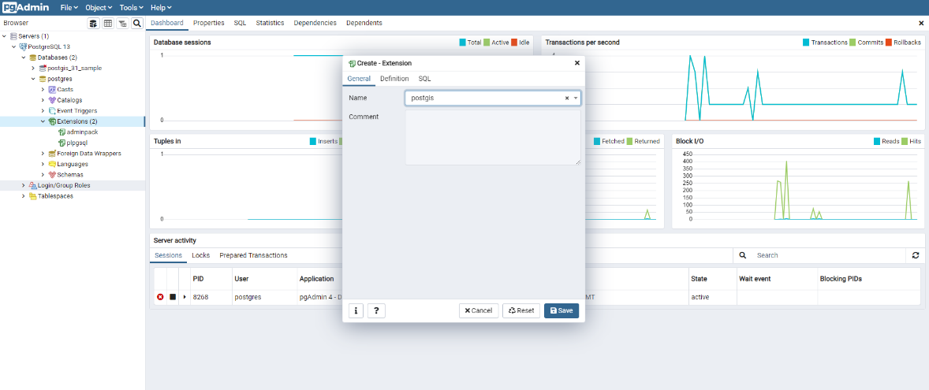

Creating database for the project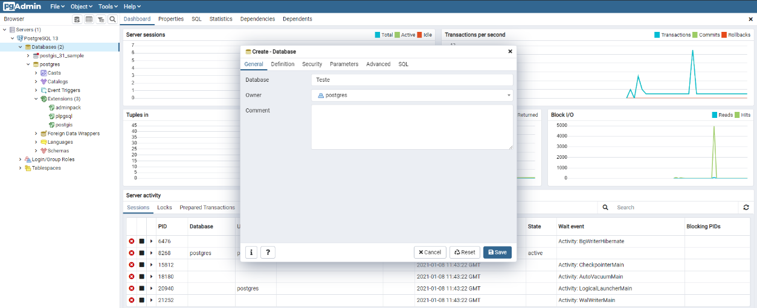

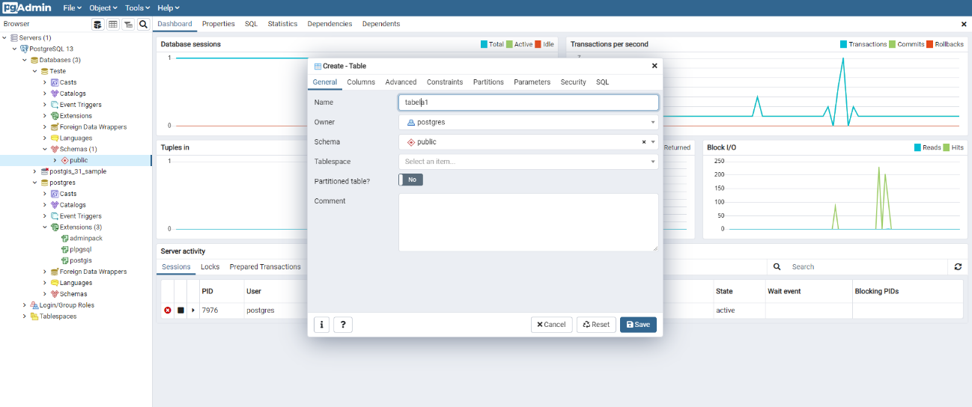Creating table. This table is going to serve as an example for how PostgreSQL displays geographic data.

Inserting into the table previously created data that creates a point, line, polygons, and collections.

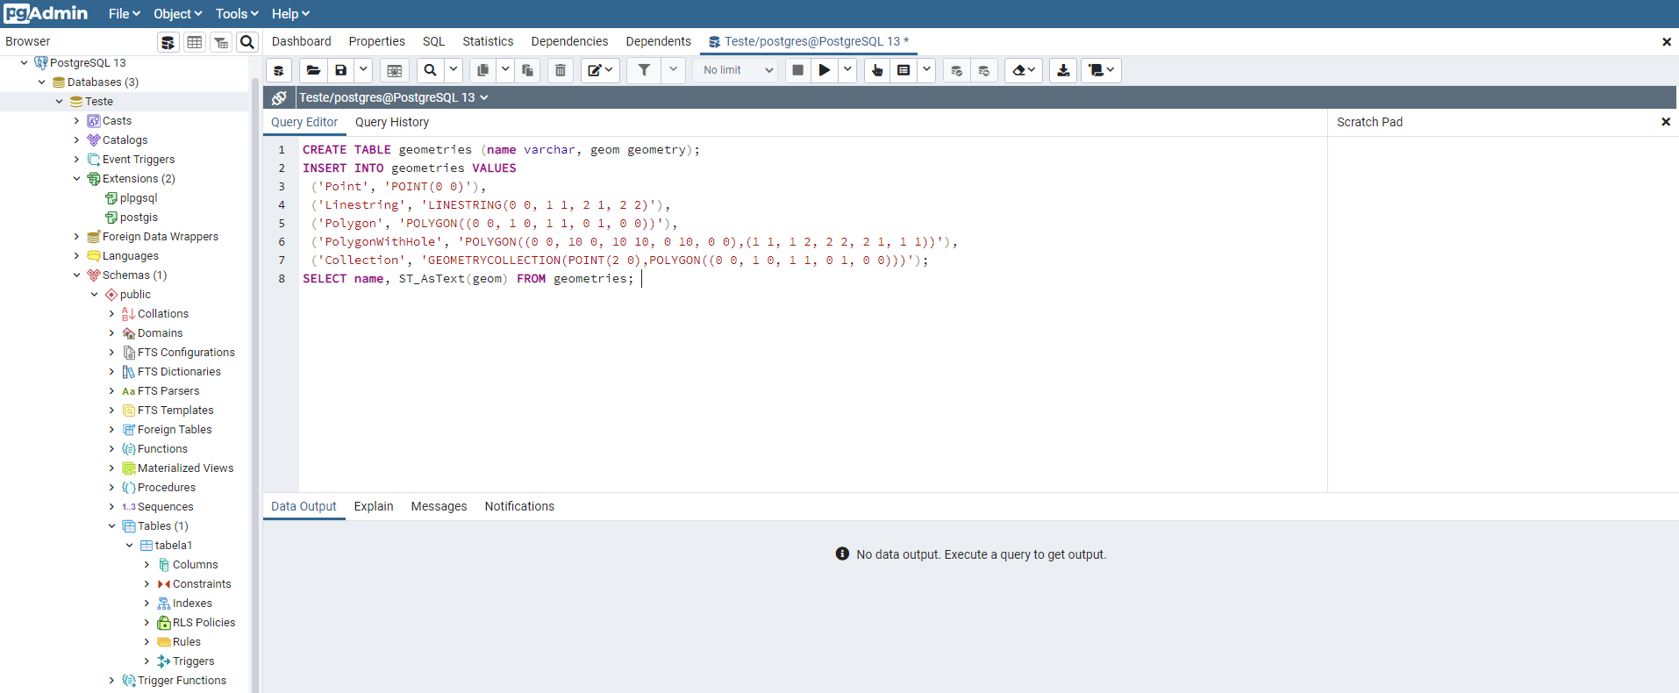

The previous select geometry table fields in string format gave the next output.

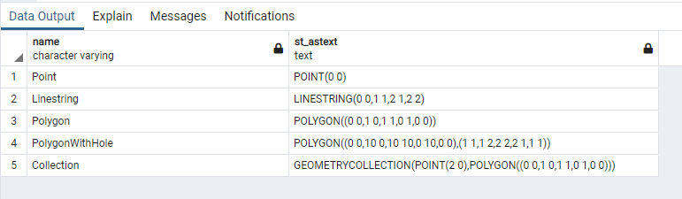

The eye allows graphic visualization of query results.

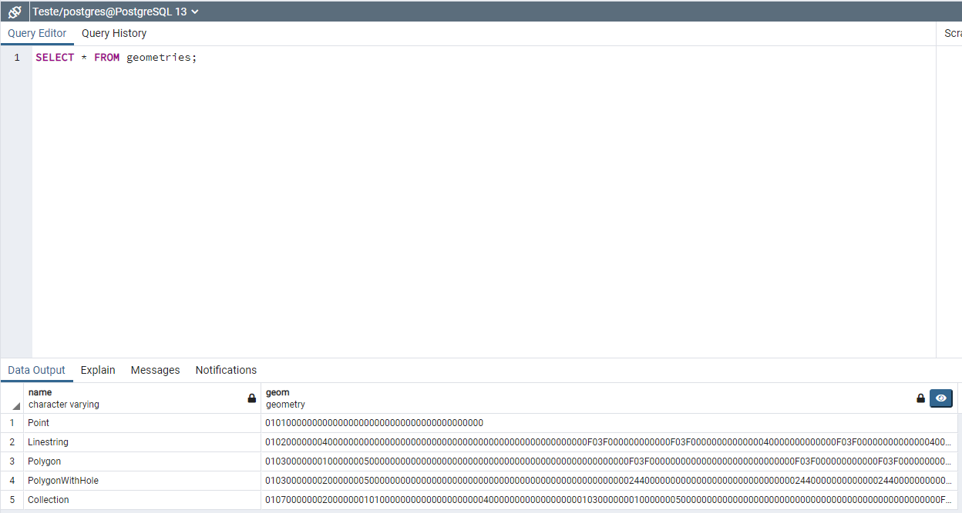

Geometry Viewer shows the representation of the geometry fields. The image it generates represents the layer that would be applied to a map.

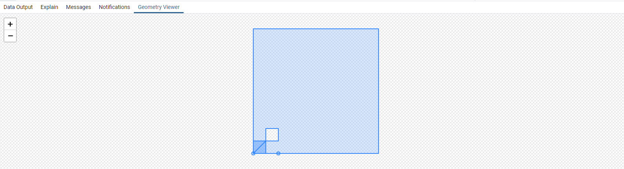

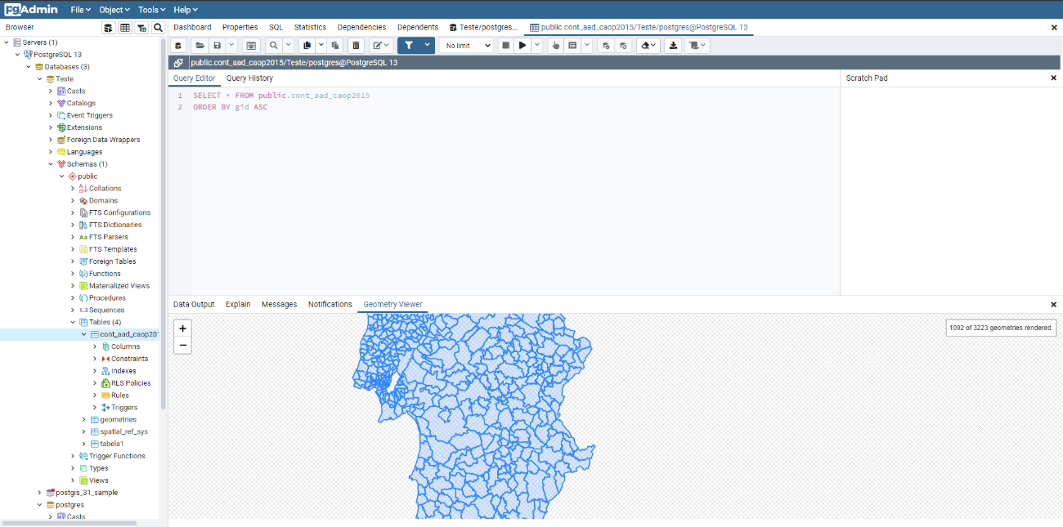The visual representation of the shape file represents all Portuguese territory where each county boundaries are outlined.

### 4.1.2 Import of Shapefiles to the PostgreSQL Database (with the geographic component postGIS)

A way to import files into PostgreSQL’s pgAdmin is by using PostGIS. In order to do that perform a connection is required.

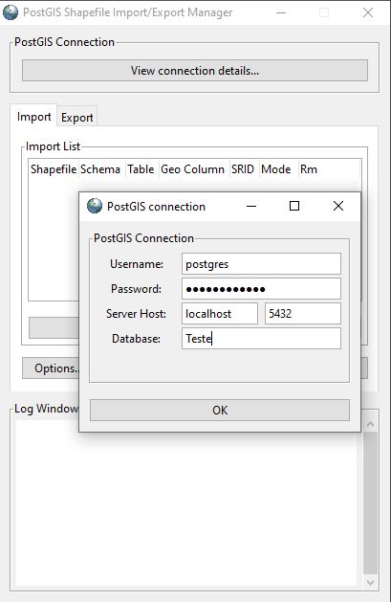

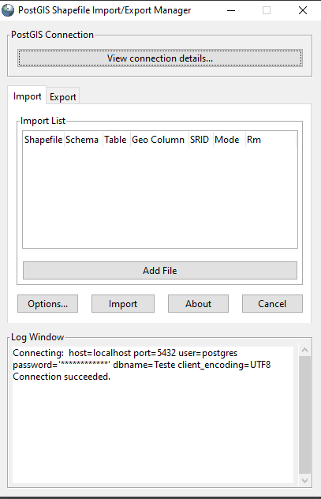

Shapefiles represent a data format that stores the geometric location and attribute information of geographic features. Geographic features can be represented by points, lines, or polygons.

With the shapefile previously downloaded from data.gov website, it is imported using PostGIS to pgAdmin.

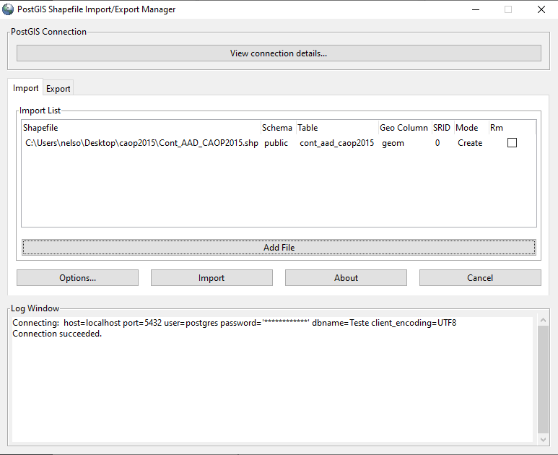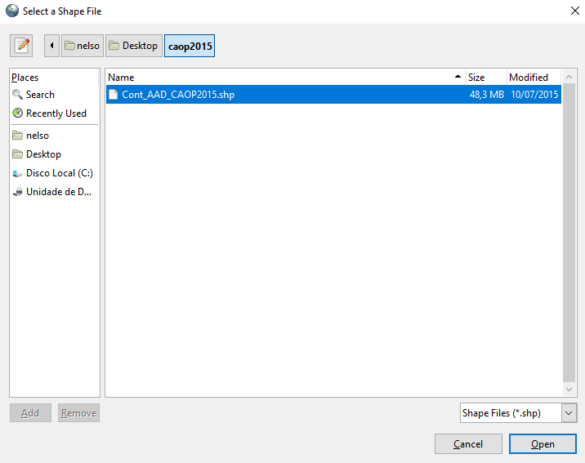

Shapefile map visualization. Represents the layer that could be imported into a map. On the next table we can verify the same type of information on the last page.

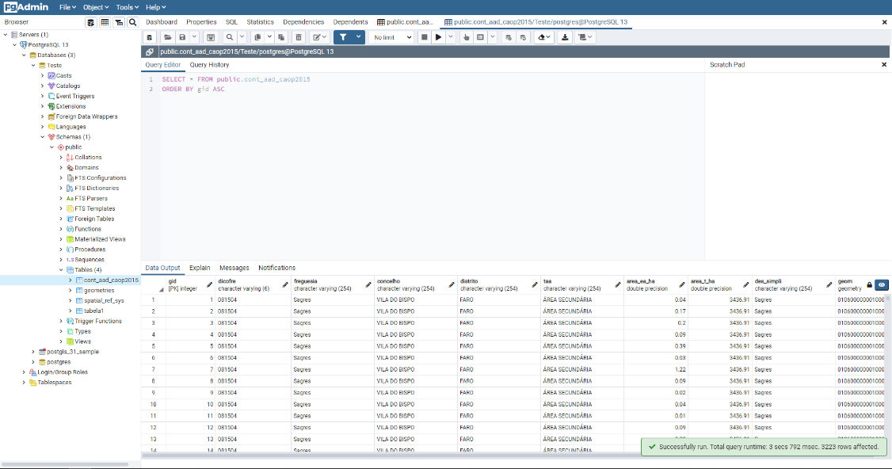

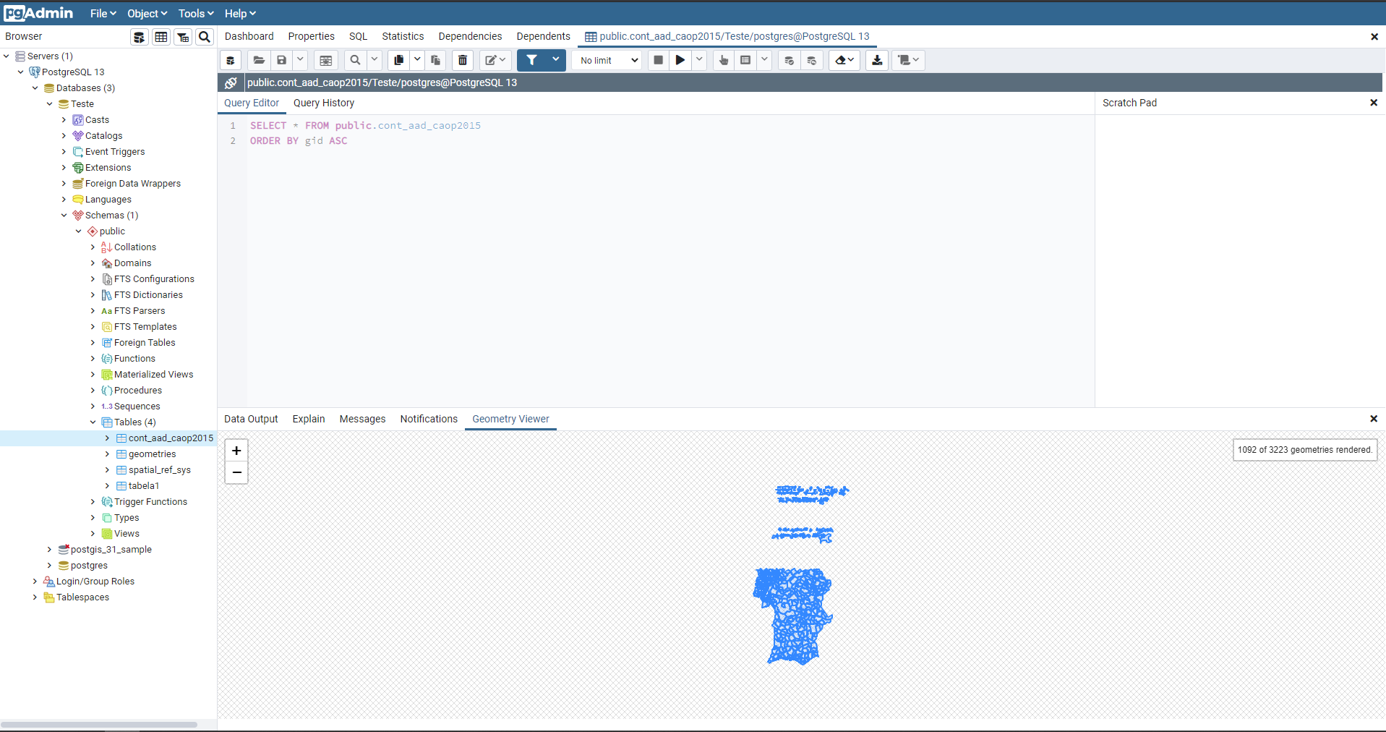

Insertion of the remaining shapefiles in the postgreSQL database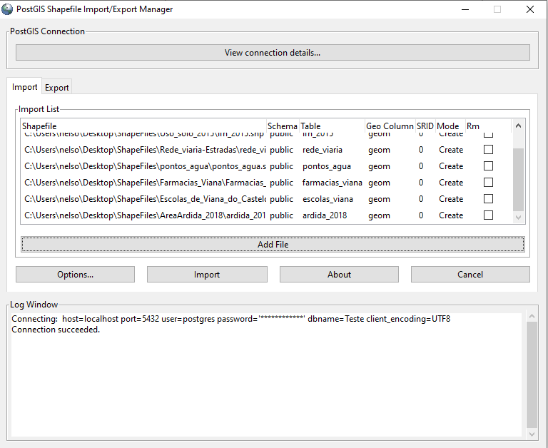.

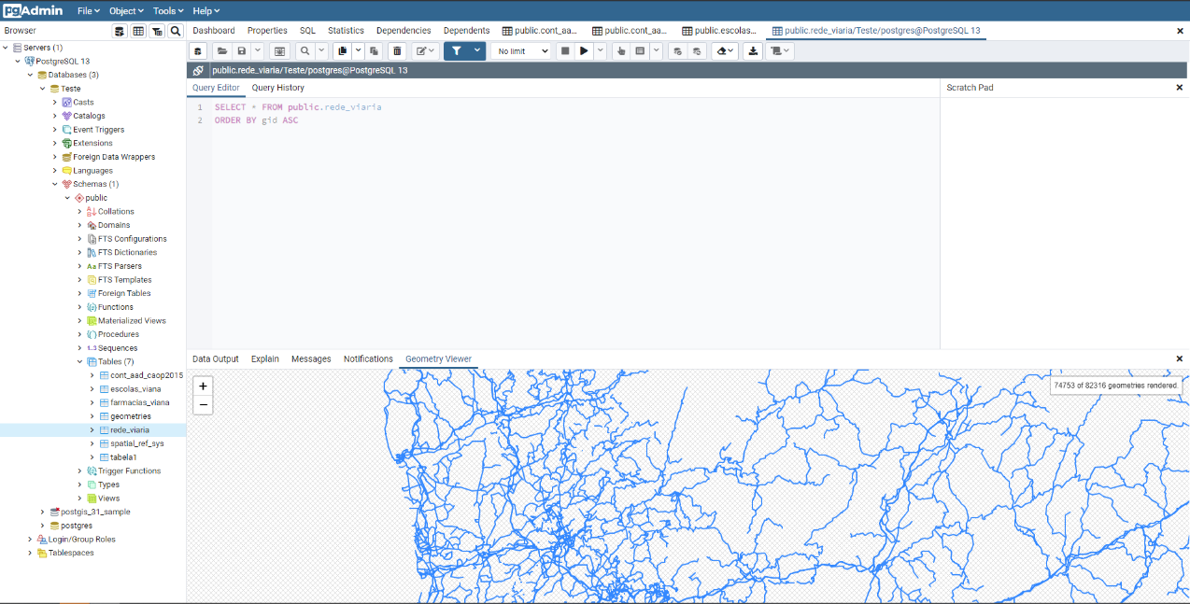The following image represents the Geometry viewer from the shapefile that contains information about Portugal’s road network.

### 4.1.3 View the information in the QuantumGIS viewer (Optional implementation)

Other ways of exploring and analyzing shapefiles is by using other open-source tools that support goespacial data. One of those tools is QGIS.

Shapefiles with information about ”rede-viaria” and “caop_2015”.

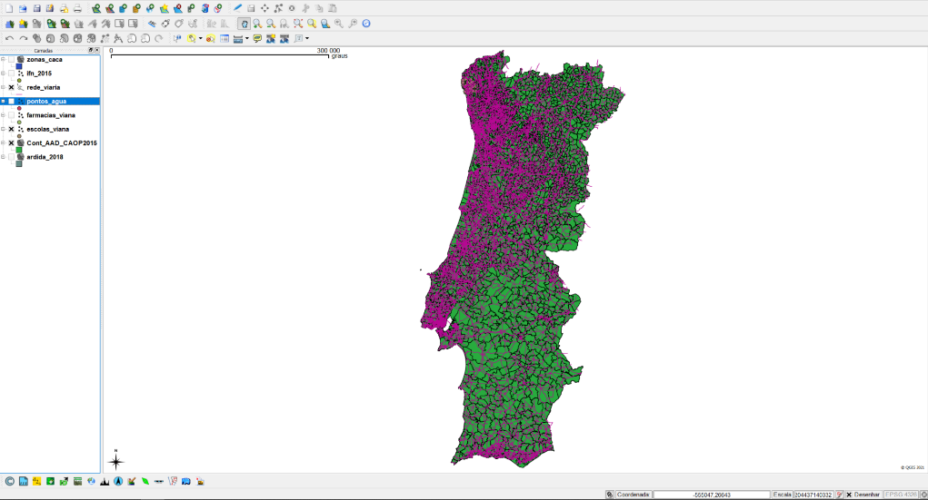

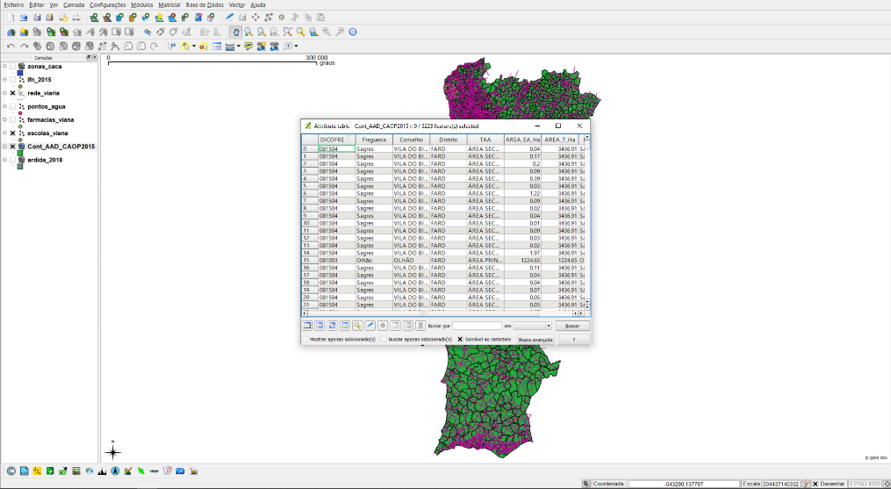

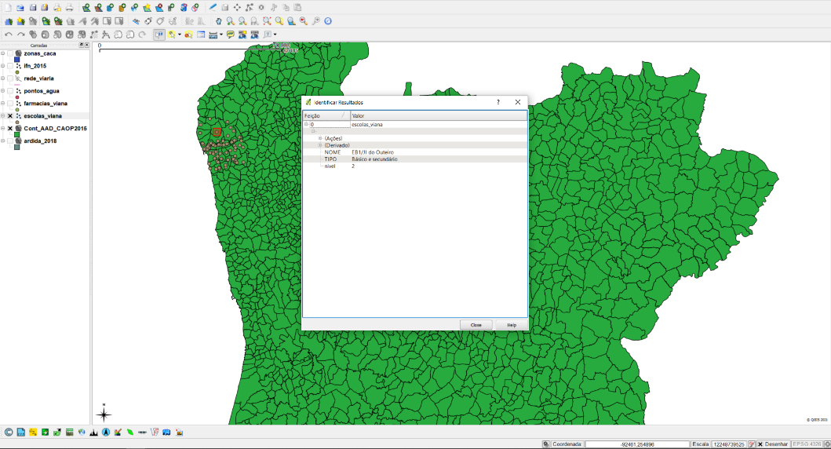QGIS has multiple features that use the data contained on the shapefiles to, for example, present personalized information about each point, line or polygon rendered using the shapefile. Points that represent schools from Viana’s district

By installing plugins on QGIS it is possible to perform searches to data on shapefiles and present only the geospacial visualization of the result. Result from ‘Braga’ search.

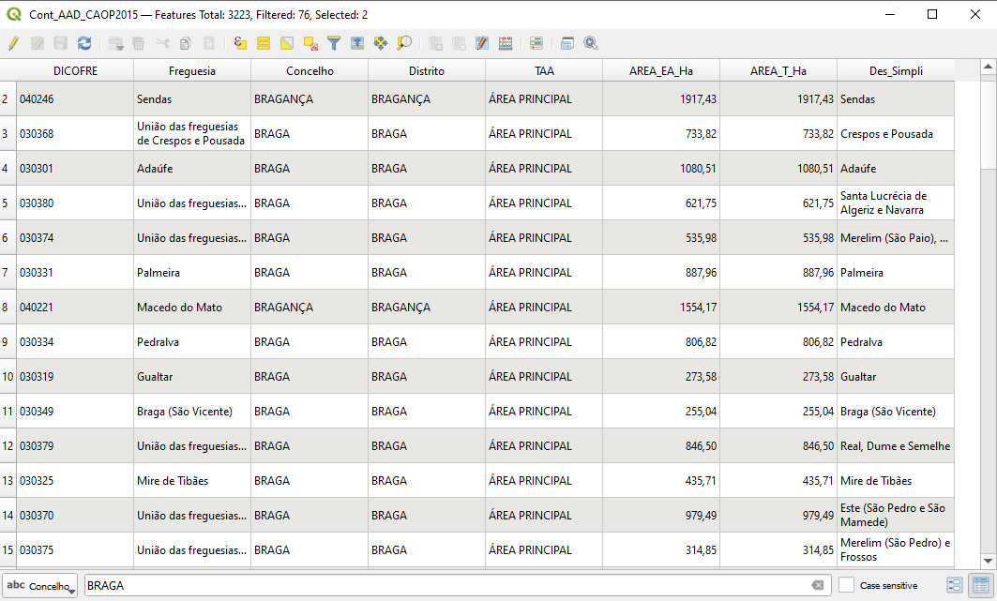

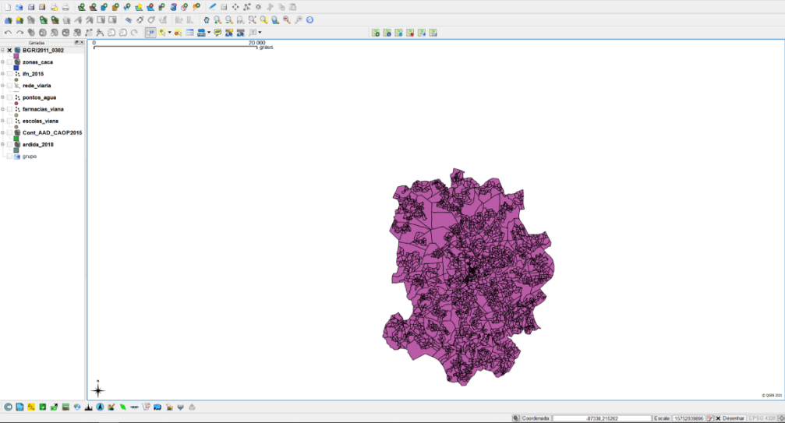

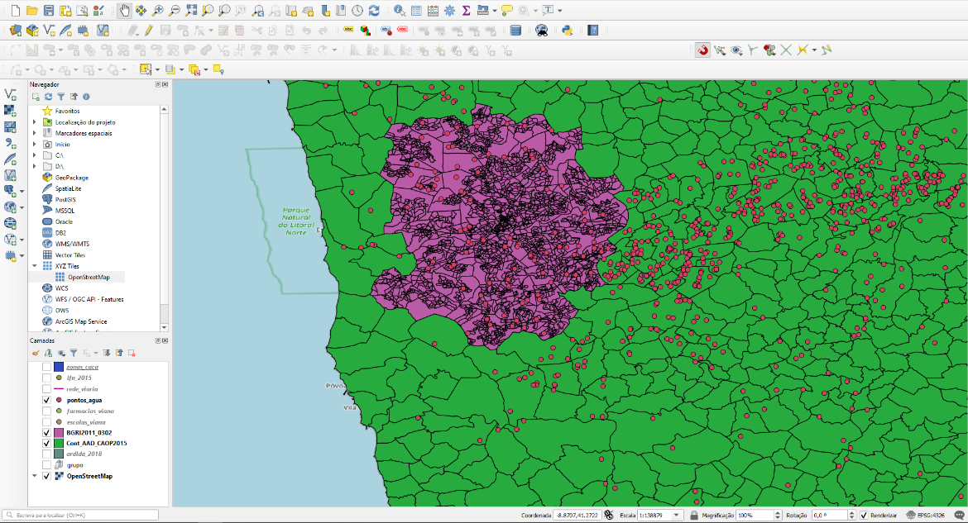All the information that appears on QGIS uses the same line of thought of regular open-source maps that can be freely used. Each information relative to a shapefile is rendered on the top of each other by layers.

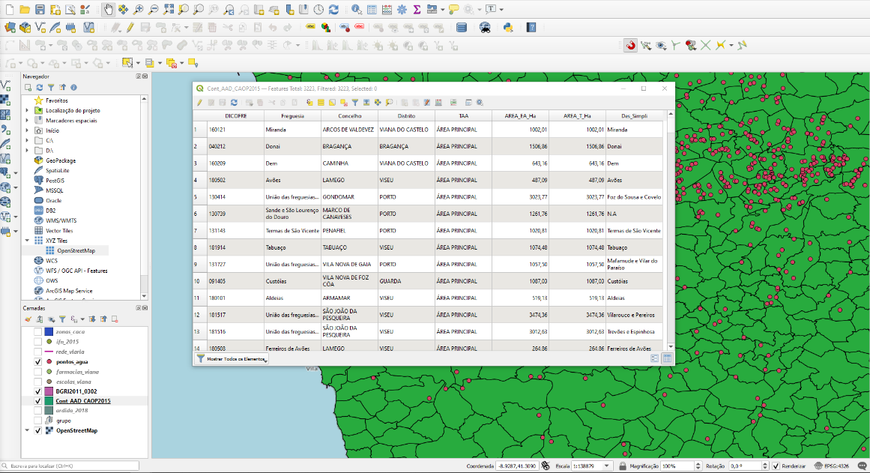Filtered information (BRAGA)

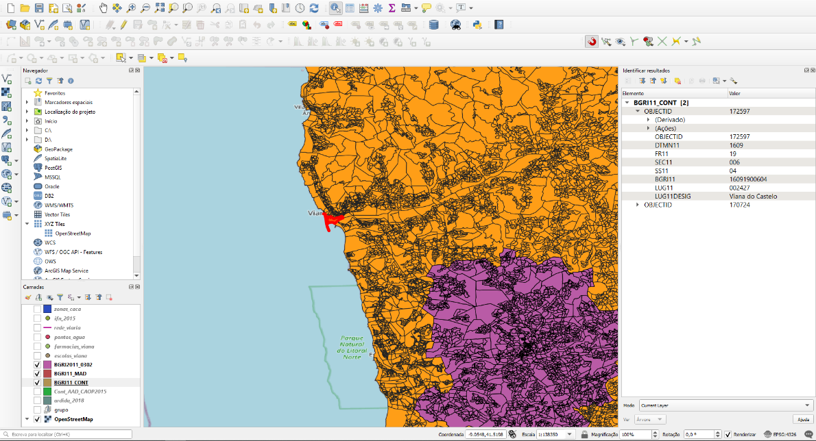Information related to the selected area

### 4.1.4 Installation of the Geoserver Mapping Server

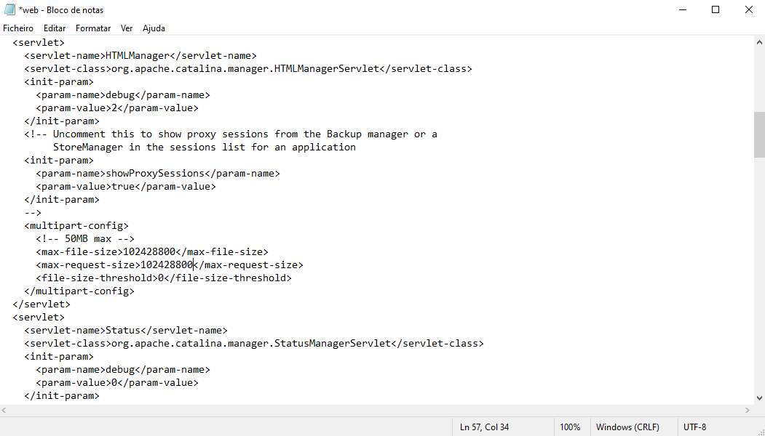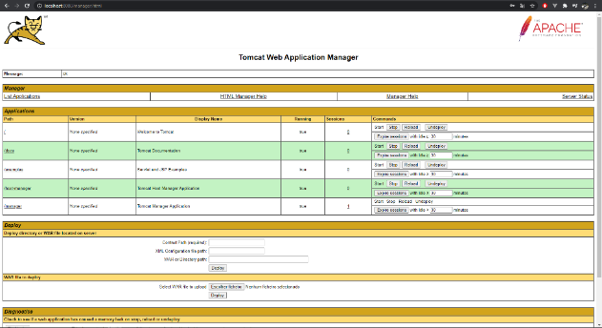To use Geoserver it is required to incorporate it on tomcat. To do so the size that tomcat allows to import war files needs to be increased.

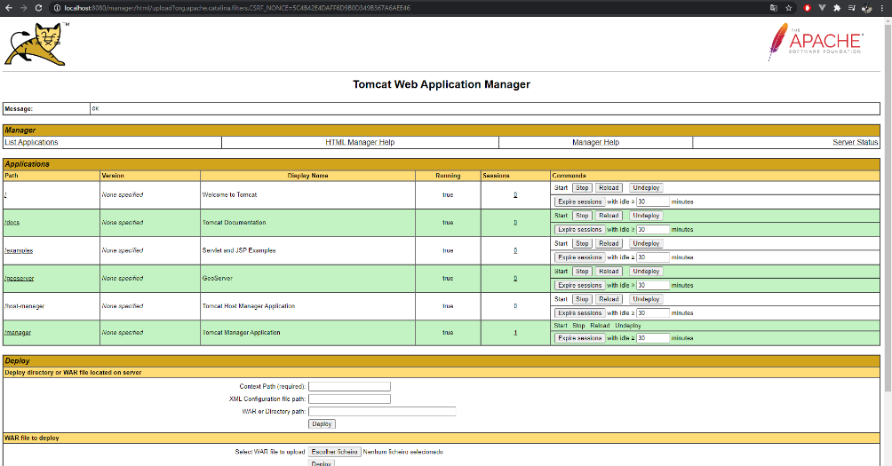

### 4.1.5 Connect the Geoserver with geographic data from the database and create WFS and WMS services

On geoserver can be created a new geoserver workspace that it is going to be incorporated alongside PostgreSQL.

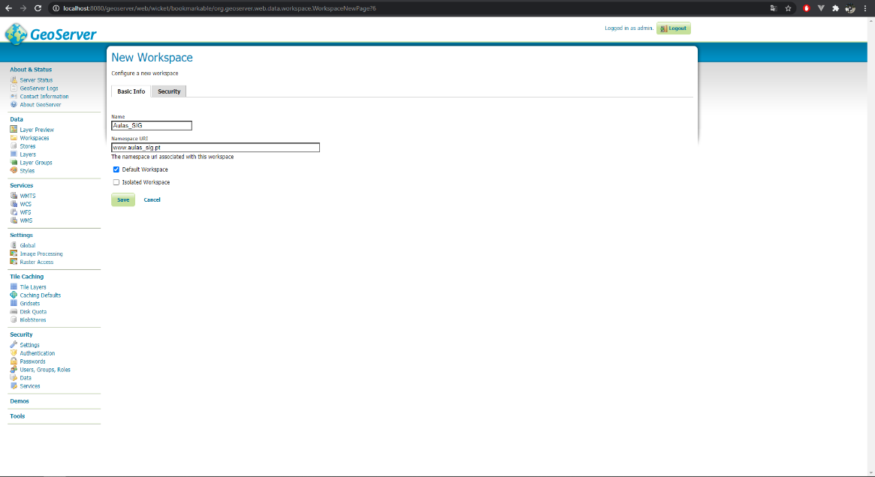

Creation of the store is necessary to hold information about a layer that represents the geometry rendering of the information contained on a shape file. These shape files are contained on PostgreSQL

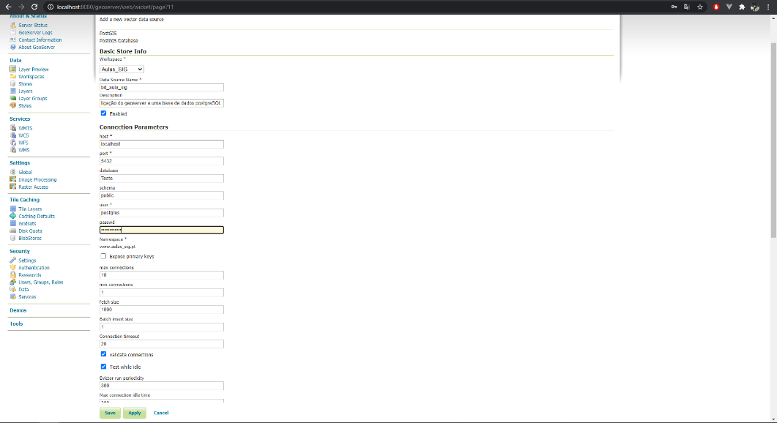

On the following image each layer represents the previously explored shapefiles obtained from data.gov. Geoserver contains layers for Portugal’s road network, counties, schools from Viana district and others.

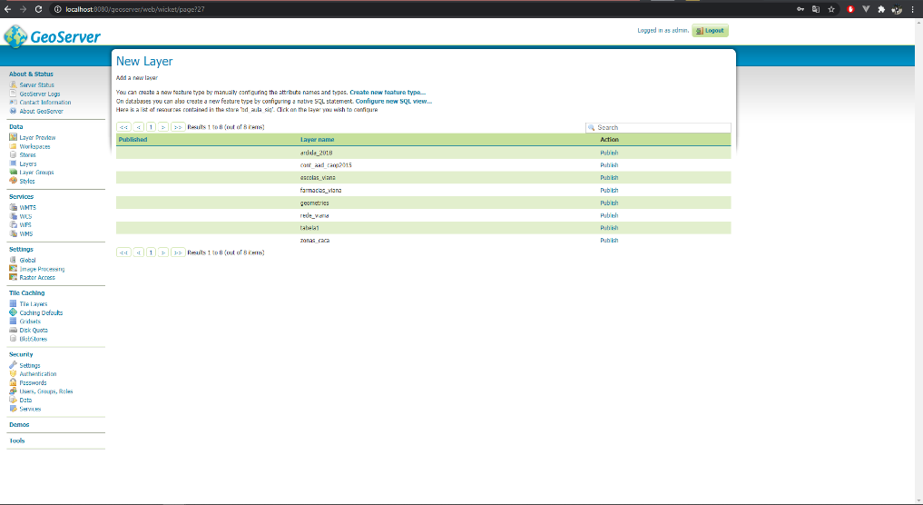

The layers contained on the Geoserver can also be edited. One of the edit and probably one of the most important ones is to make sure that all layers use the same coordinate system or else some layers may appear on the map because of it.

In this case the coordinate system that is going to be used is 3763 (Portuguese coordinate system).

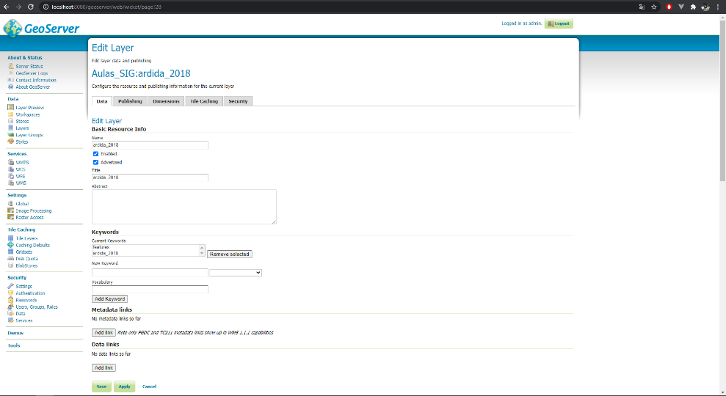

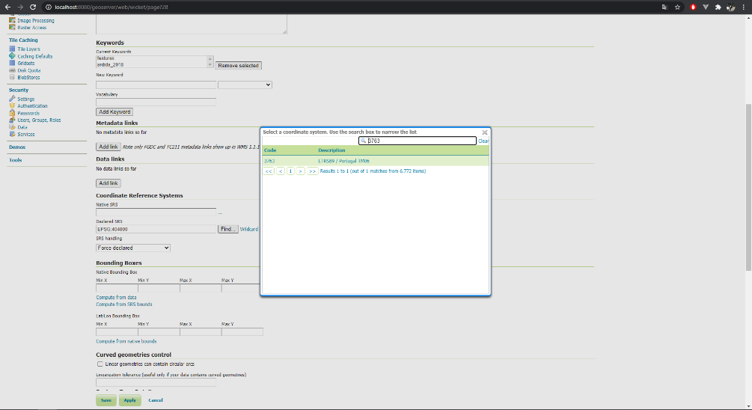

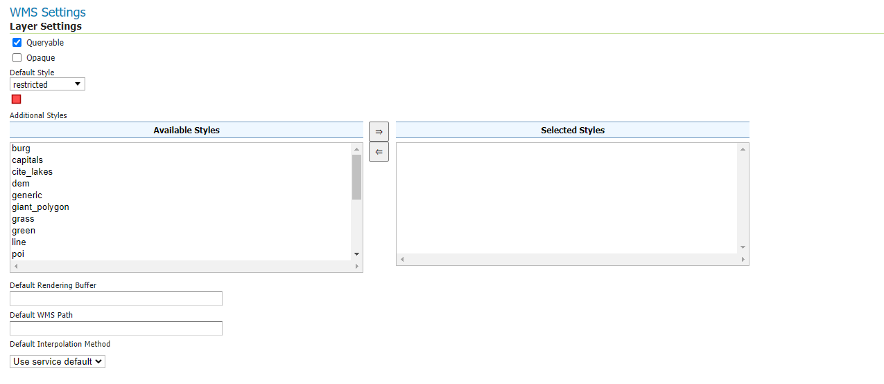Styles. How the information obtained from the shapefile should appear on the map

Forcing the coordinate system type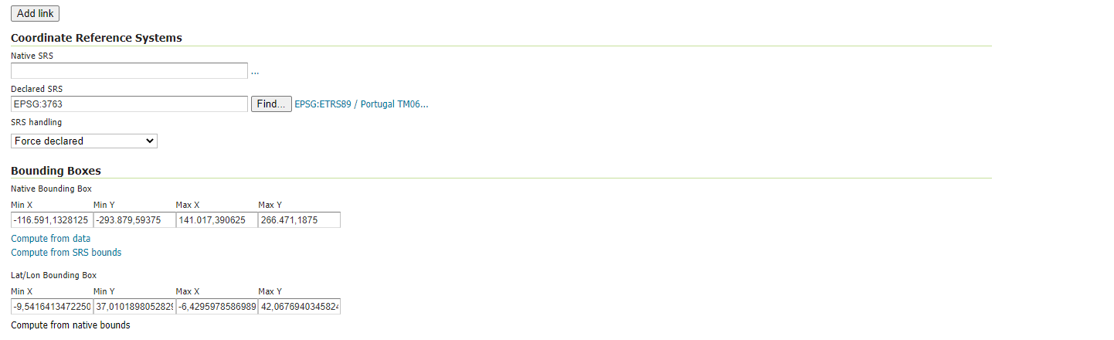 to 3763

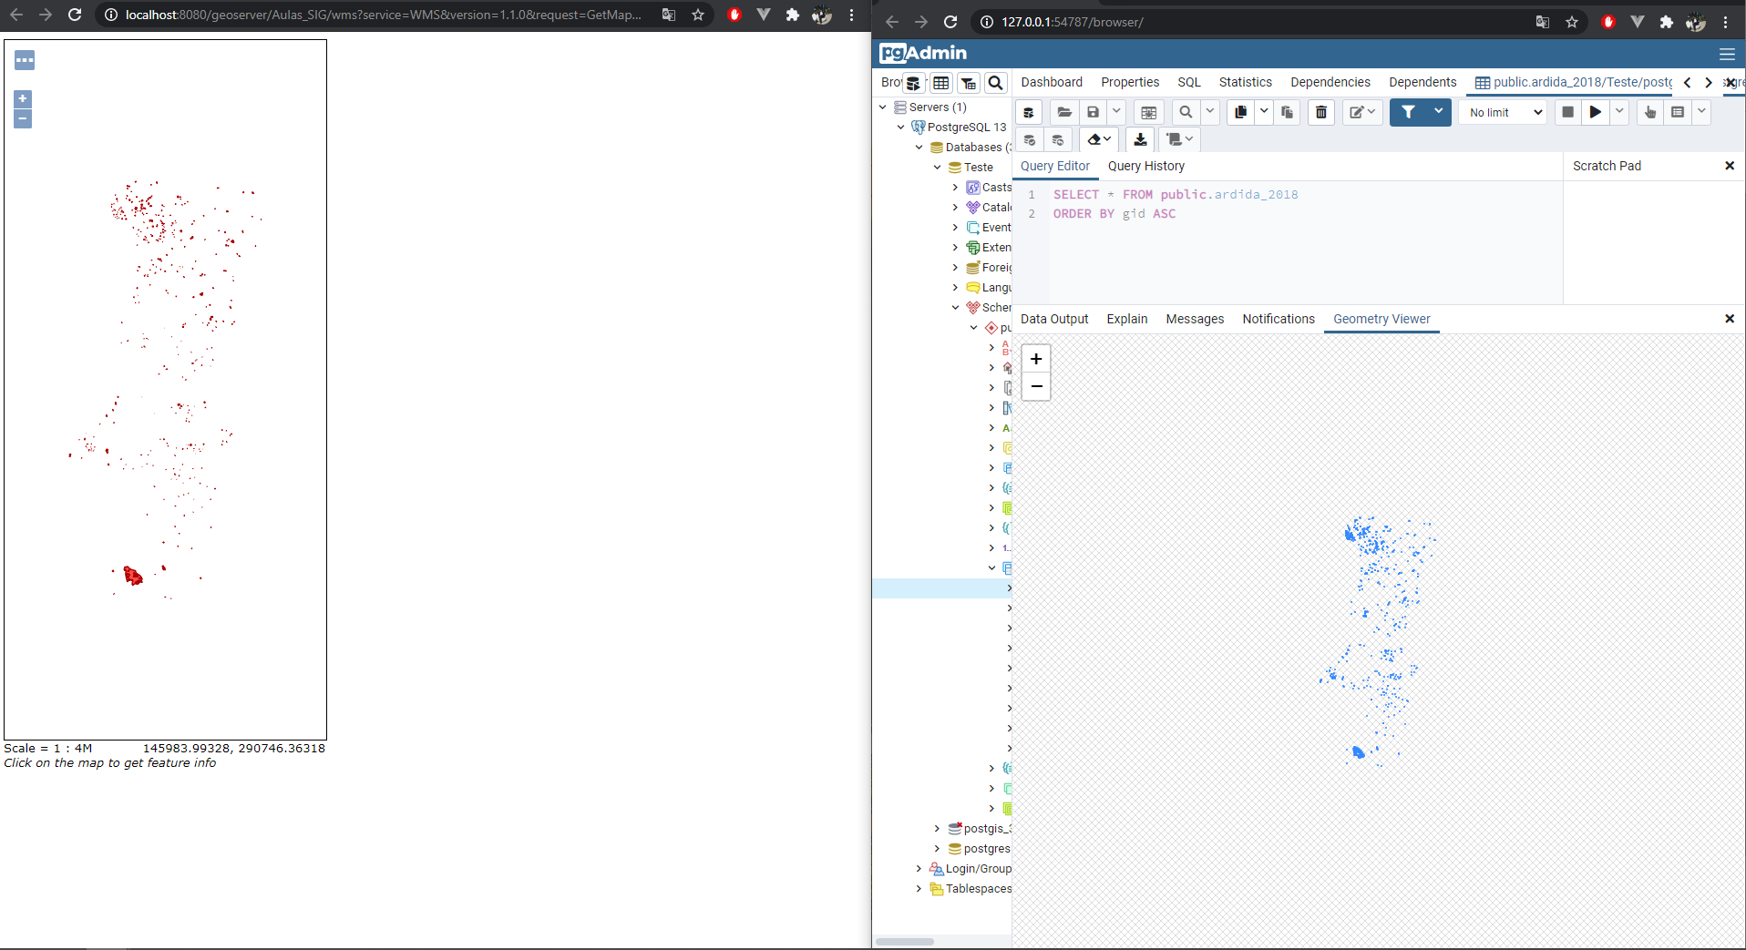The result of the editing is as follows on the image. On the left is the layer created on the geoserver (that can be imported and displayed on a map) and on the right is the query result on the same table that is being used to create the layer on the geoserver.

Shapefiles refering to countries Shapefile refering to Portugal’s road network

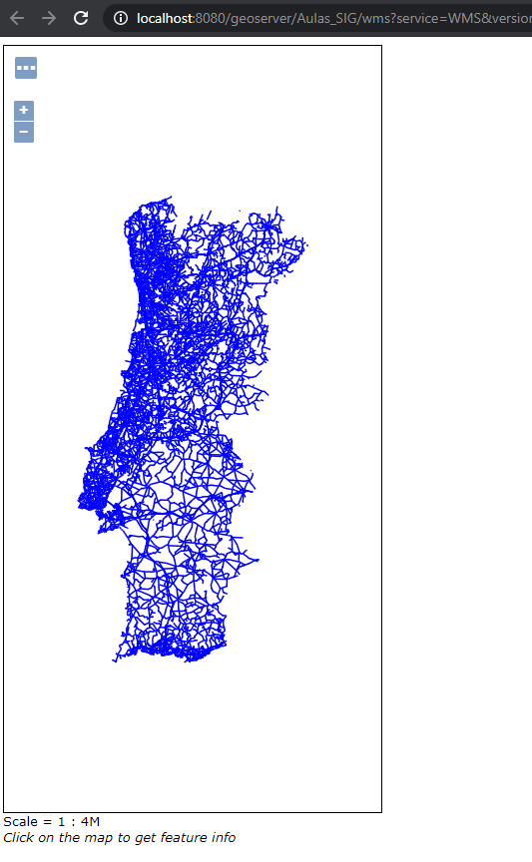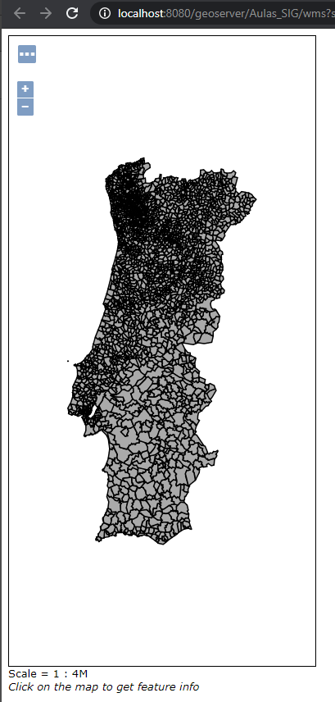

Shapefile refering to water spots

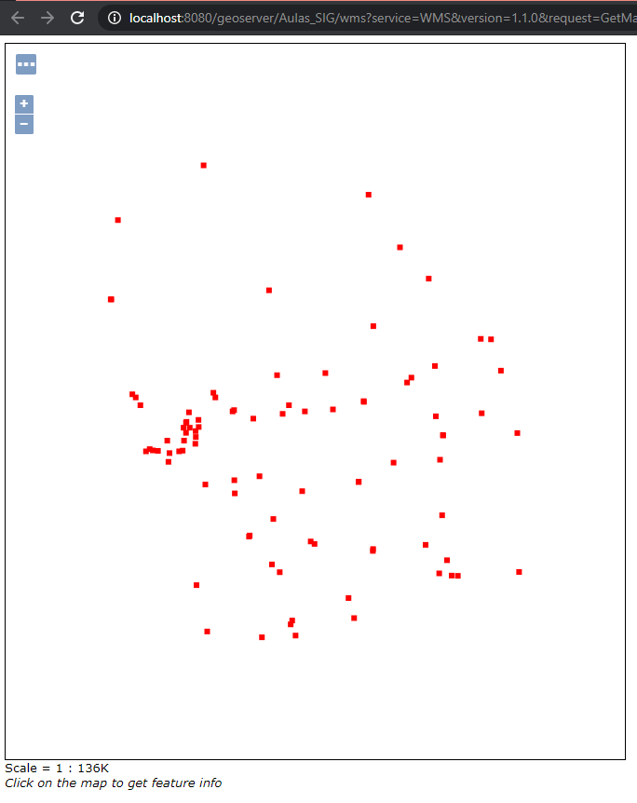

Downloading shapefile refering to ‘Ecopistas’

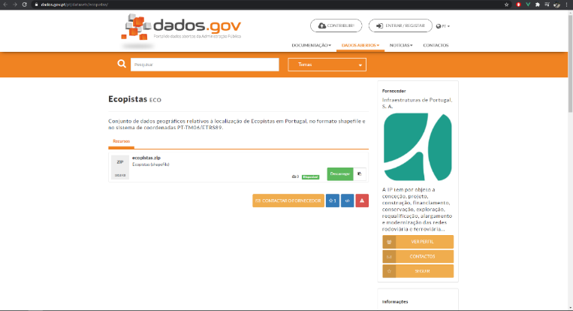

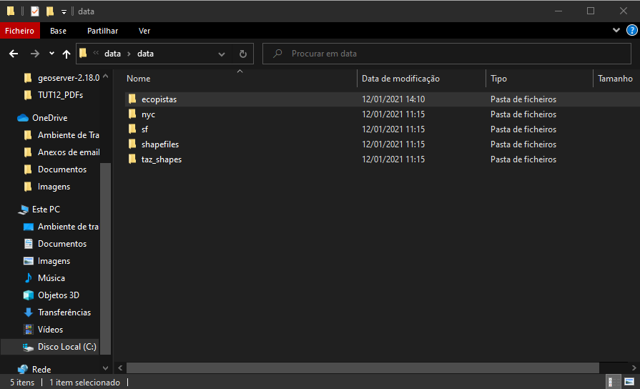

Adding new shapefile to Geoserver to create a new layer.

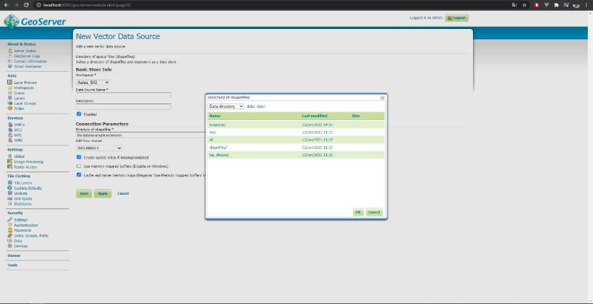

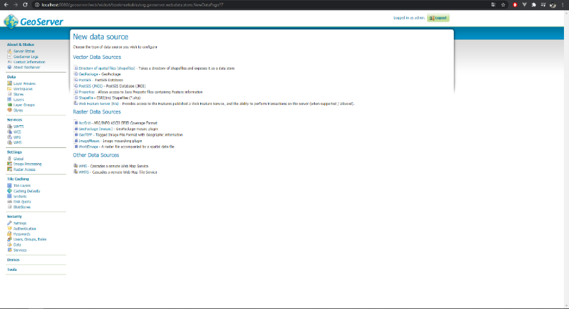

Layer created and visual representation of the layer.

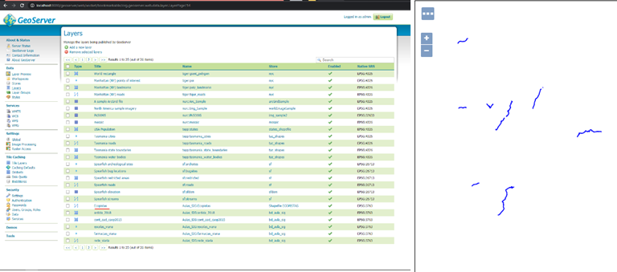

On this example it is obtained a WMS file to create a layer on Geoserver.

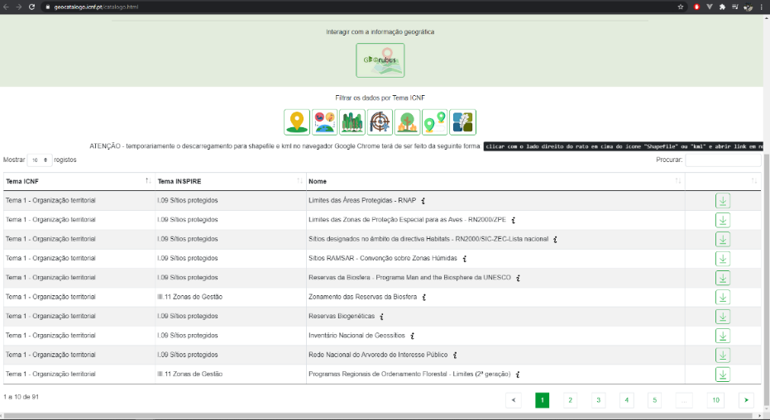

WMS (Warehouse management system) allows to obtain information, via URL, without the need of files. Like this it is possible to obtain geospacial information to render layers without having shapefiles.

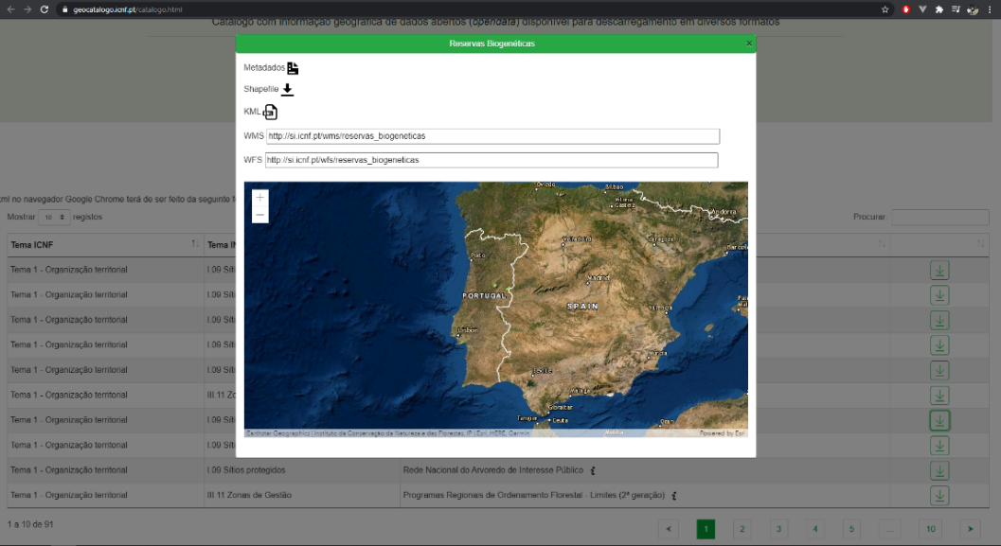

Creating a new layer (store) using WMS instead of shapefile.

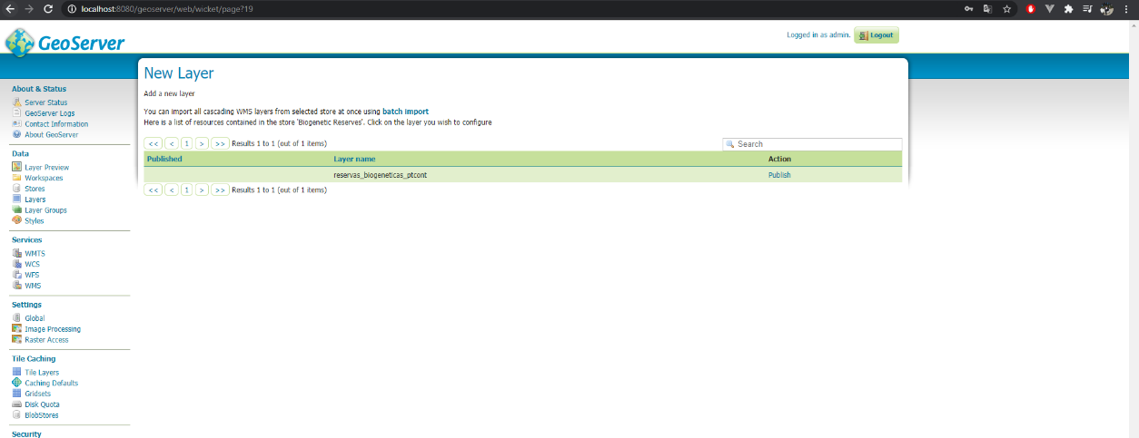

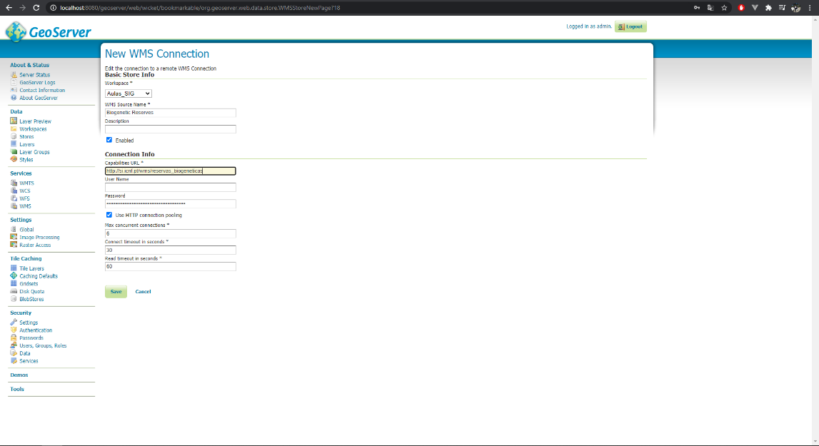URL of WMS relating to the information for the new layer about biosphere reserves.

On the following image is represented the layer created using WMS.

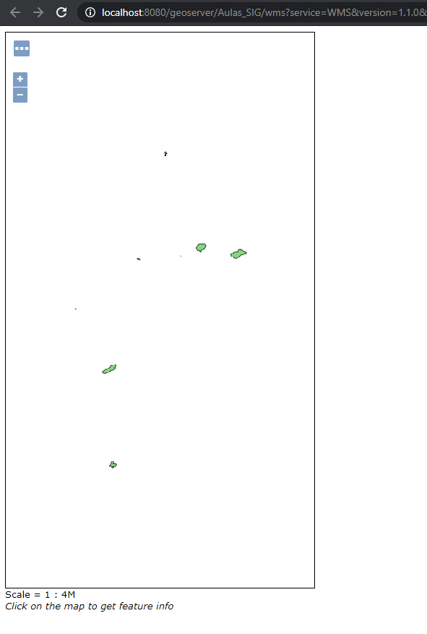

### 4.1.6 Visualization of Geographic Information via WebMaps (OpenLayers and Leaflet) - Information / Basic Tutorials

OpenLayers is an open-source Javascript program that allows easy incorporation of dynamic maps into a webpage. Here it is showing a small example on how to create show a small map into a web page.

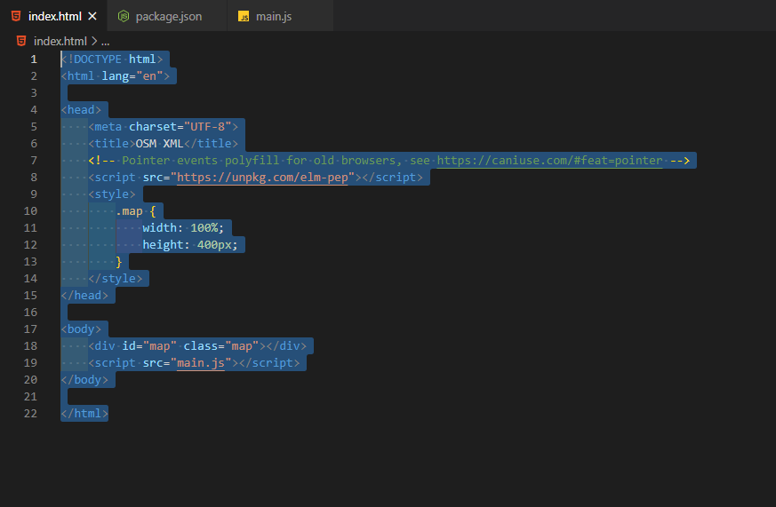

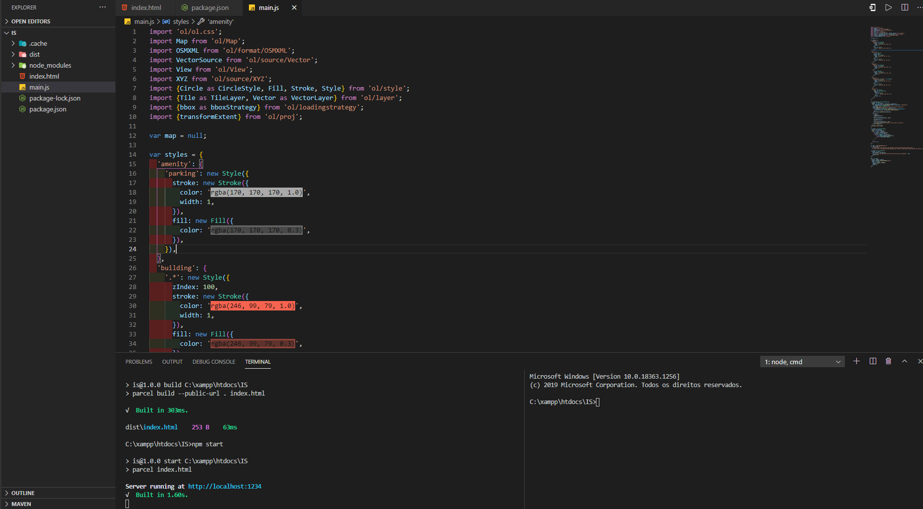

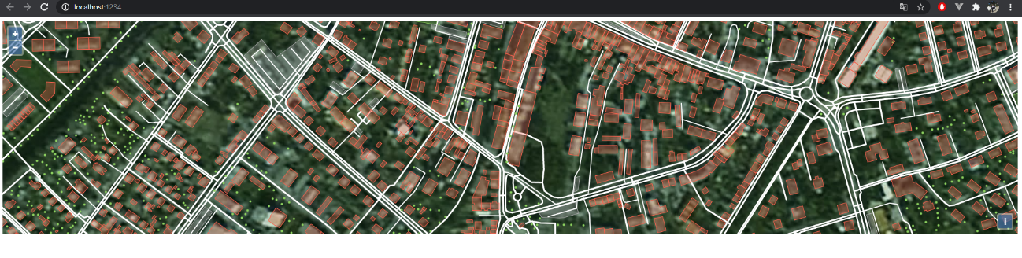

## 4.2 Final Project

### Postgres

In this project the postgres database with postgis was used to use geometry type fields.

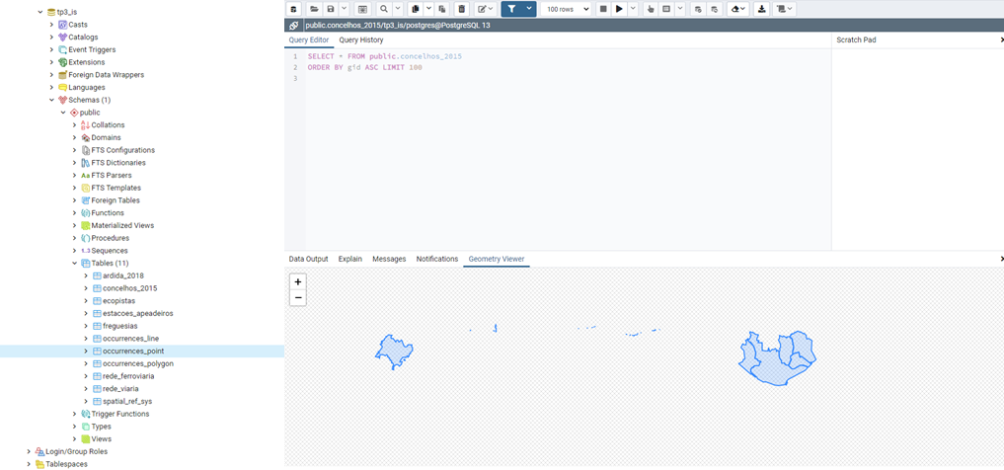As you can see in the following figure, we have various tables that were used throughout the project. We have tables that represent shapeFiles imported into database as "concelhos_2015" or "ecopistas" and tables that are receiving data sent inserted in the forms on webpage.

### Geoserver

GeoServer is an open-source server for sharing geospatial data. This allows reading data from a database (PostgreSQL with PostGIS) and also allows reading external services like WFS and WMS.

In the following figure it is possible to see that "Fotopontos" were inserted in the geoserver as a new store (WMS). Through this store it is possible to create a layer represented also in the figure

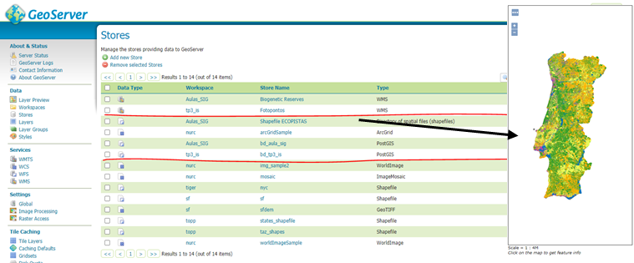

Also, on geoserver, a new store was created to access the data inserted in postgres. Through this store several layers were created. These layers represent each one, one of the database tables. The following figure shows the tables used to insert points, lines, and polygons on the map and “concelhos_2015” shapefile.

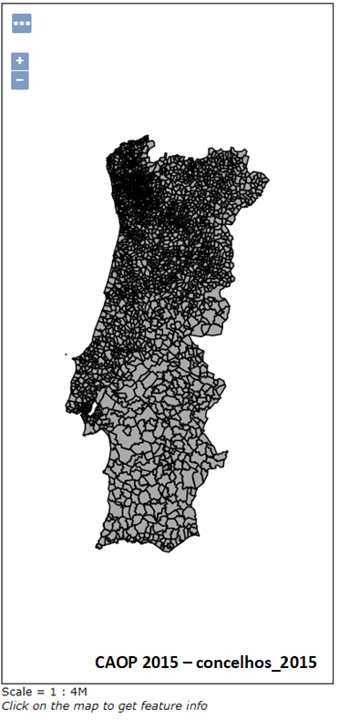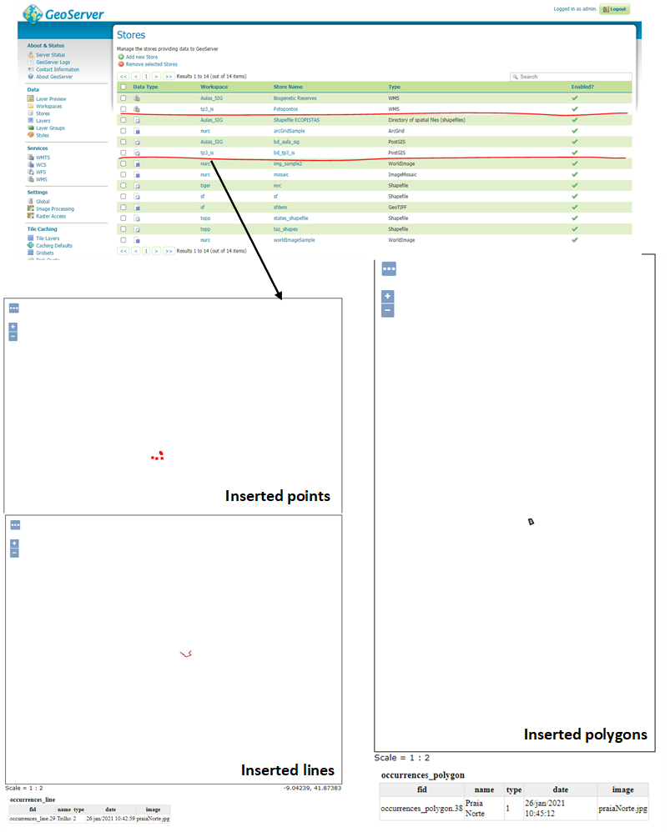

### WebSIG Viewer

In the project to create a WebSIG viewer an html page was created with the necessary scripts for inserting a leaflet map. To be able to view map, a div with id = "map" was added to the body of html to have a reference to the div and also, so that afterwards it could be stylized and appear on the entire screen.

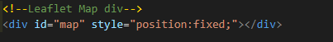

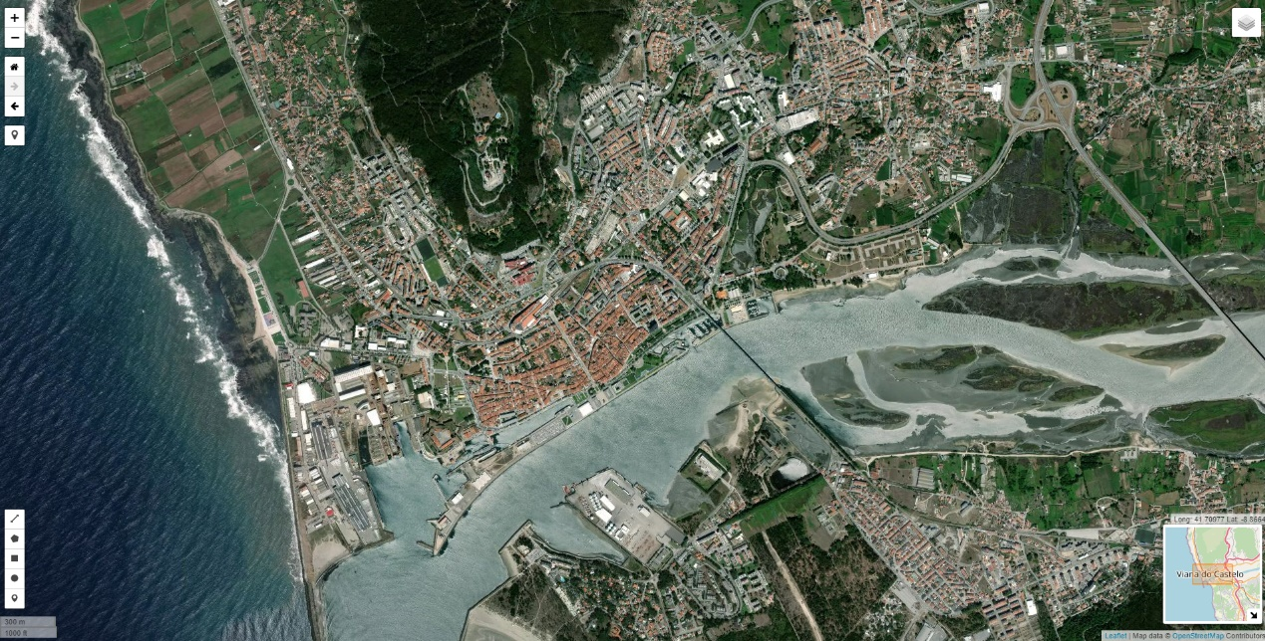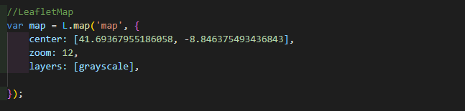Definition of the map in leaflet to be added to the div previously created. In this variable, fields were added to center the map, the zoom that the map must have and the main layer of the same.

To make the project more visually appealing, several layers were added to leaflet map. The added layers were obtained from openstreetmaps and the mapbox. These layers were then added to a side button that the leaflet map has, so that user could choose layer they like more.

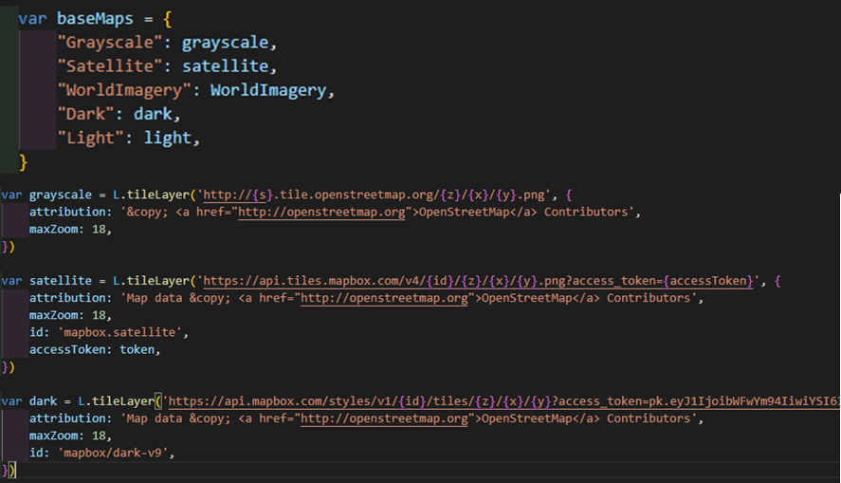



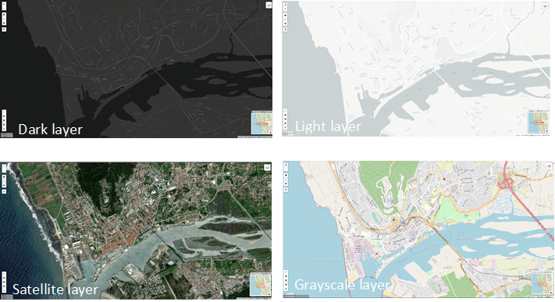Examples of declared layers:

As was intended in this work, the layers inserted in the geoserver must be visible in the leaflet map, thus, variables were declared. Each of these variables represents a layer of the shapefiles inserted in the database or wms services used in the geoserver.

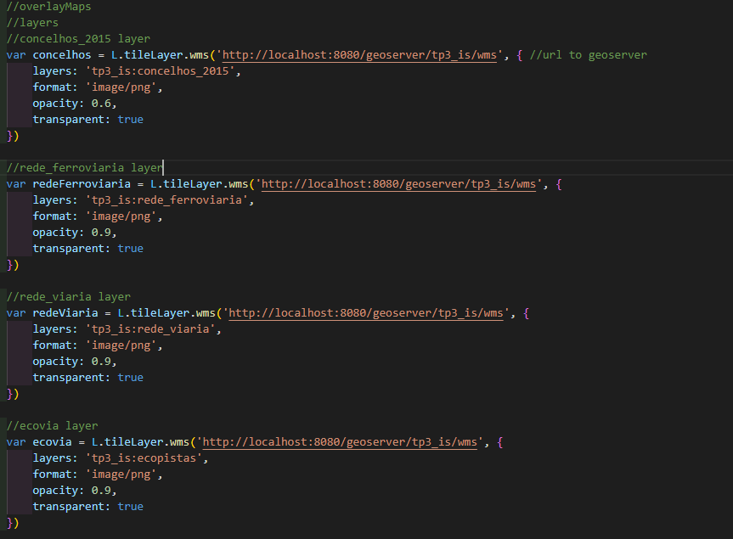To access the layers, a request is made to the geoserver installed and hosted on the port: 8080. These requests have parameters that indicate which of the tables must access.

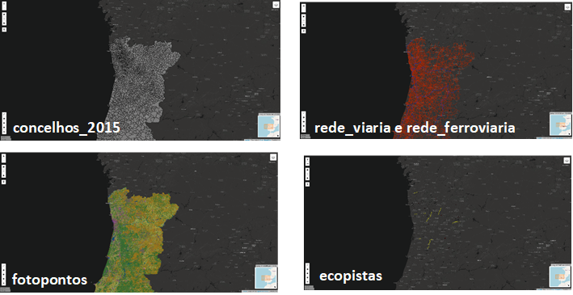

The leaflet map contains buttons from the leaflet itself for drawing points, lines and polygons. The following figure shows how these "markers" should be added, that is, the style that should be applied to each "marker" type.

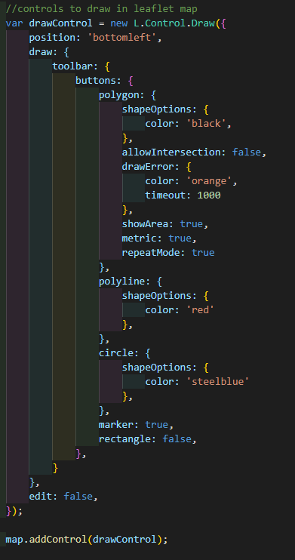

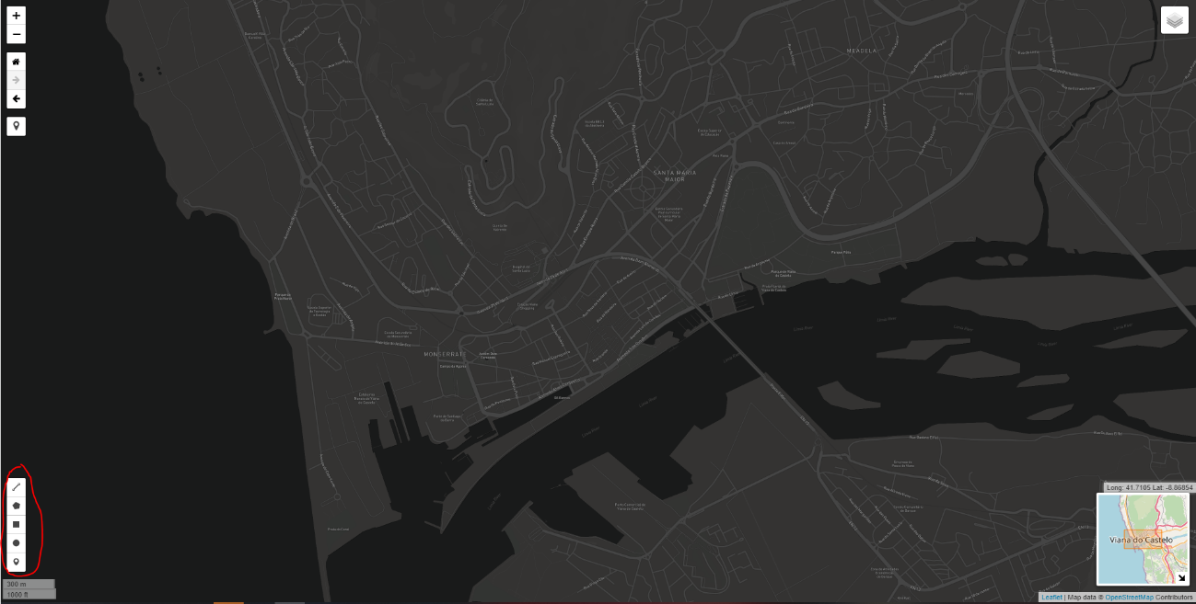

**drawControl**

This code excerpt allows each draw click on the map to trigger this function. In this function it is verified what type of shape is being inserted, then, through the type of shape, it is redirected to a new function that opens a modal form with the data that must be inserted to save the drawn shape.

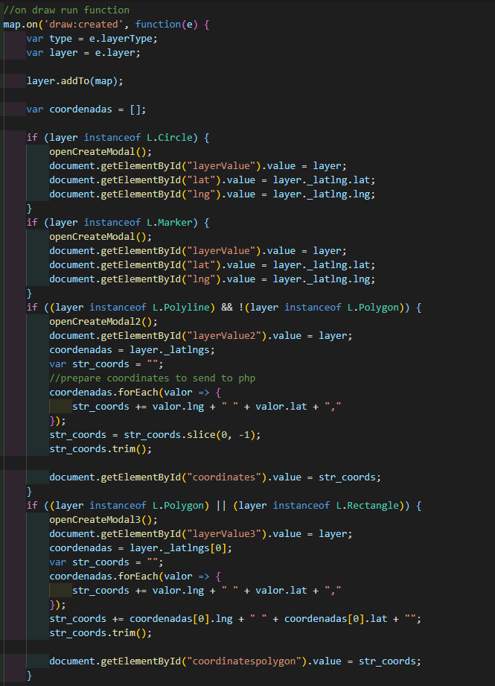

Modal for the insertion of a new point, polyline, and polygon on the map. Each type of marker has a name, type and image identifying the place.



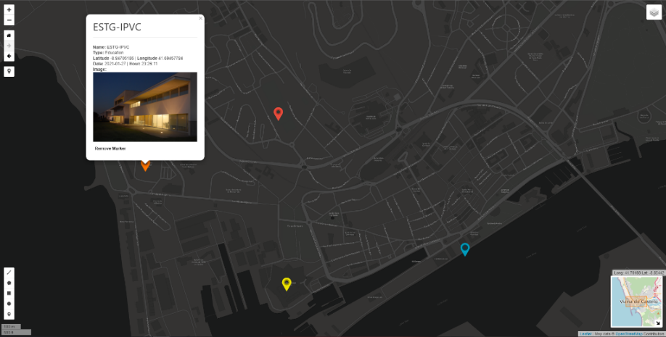

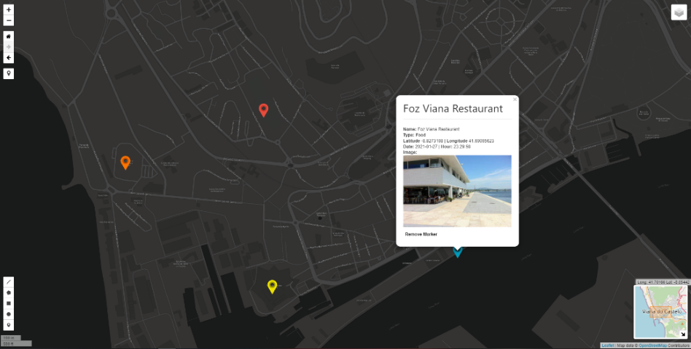

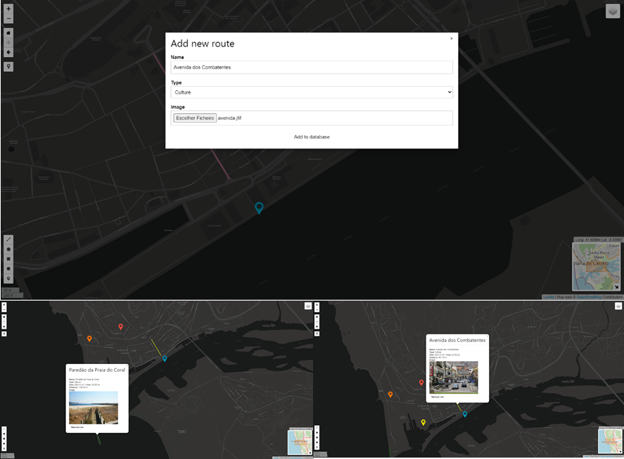Add new route

Add new area

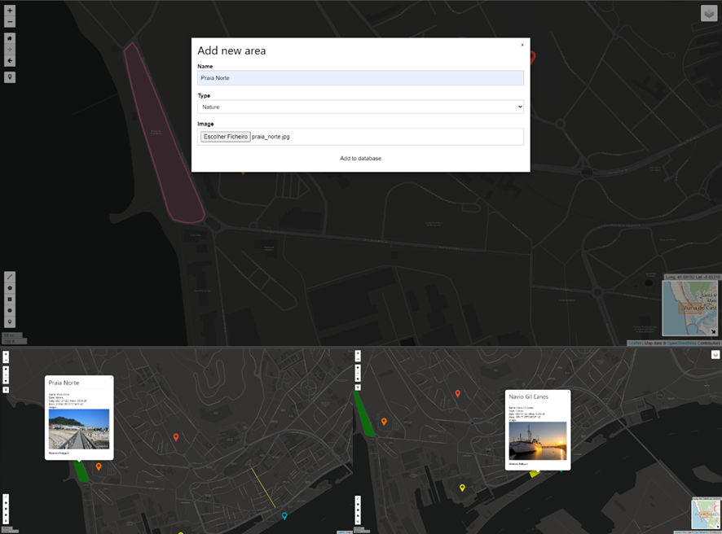

The following code shows how the data that was entered is placed on the leaflet map. A request is made to the geoserver that returns a json with the information, in this case the marker. This information contains the coordinates and everything that was inserted when defining the new marker. In this way, it is possible to create a popup with data such as name, data, latitude and longitude, type of marker and image. In this popup is possible remove that from database.

Depending on the type of marker, the icon has different colors on the map.

This applies to markers, polyline and polygon.

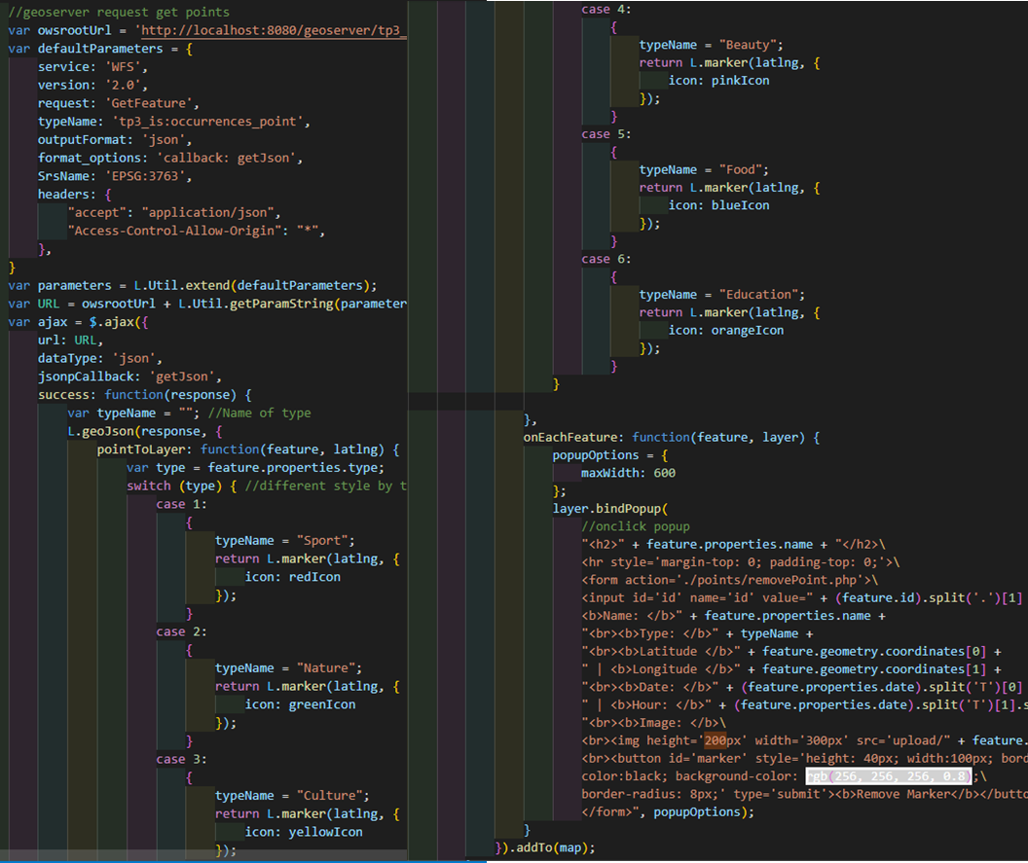

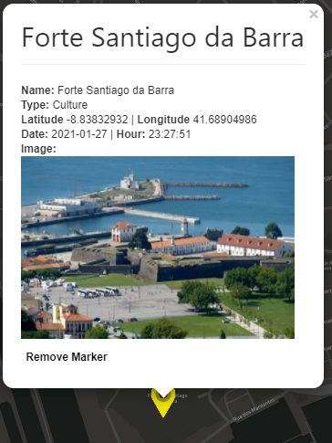

**Marker Popup**

**Polyline Popup**

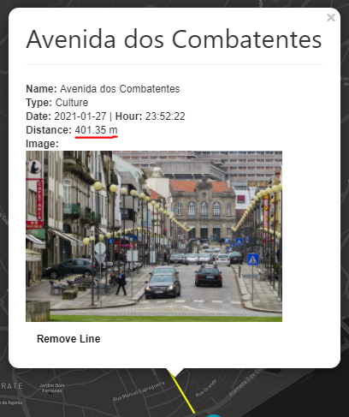

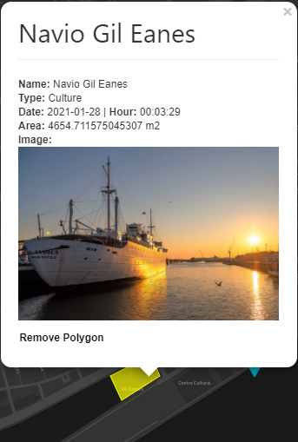

**Polygon Popup**

### Database connection (php)

To access the database, we use the php language. So, we had to insert the data related to the database we wanted to access. We then had to enter the username, password, host, database, and port.

We used the PDO for this connection. The PDO or PHP Data Objects extension defines a lightweight and consistent interface for accessing databases in PHP.

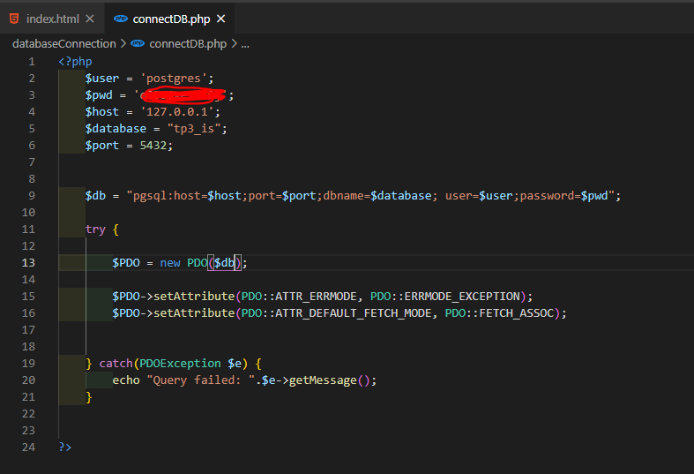

**Add data to database**

The information is inserted into the database through a query present in the following php code.

In the following figure you can see that the connection to the database was imported so that we had access to it. Then, the reception of the data entered in the modal form, previously presented, is verified. If these data exist, they are placed in variables and the path that will receive the image is still defined.

Then the image is moved and in case of success the data are inserted in the database.

In the case of the marker, a "ST_GeomFromText ('Point (lng lat), 3763)" is made in the query, which transforms the received coordinates into text for a point that will be accepted in the geometry field of the database. These points will be in the SRS of Portugal (3763)

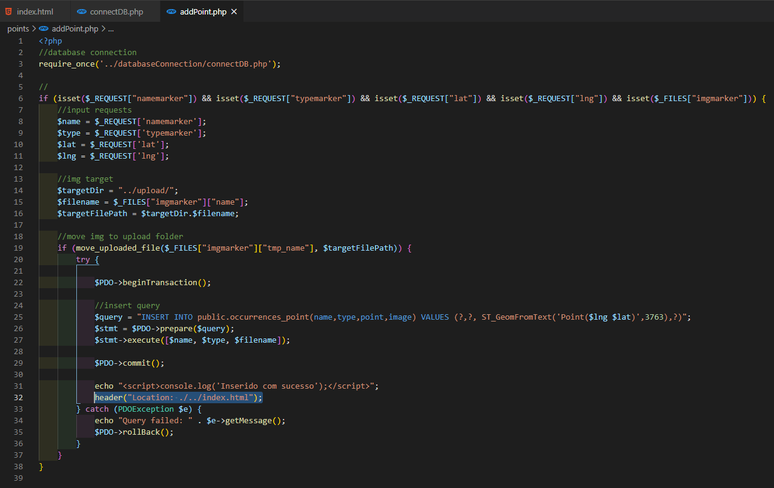

In the case of the polyline, a "ST_GeomFromText ('LineString(coords), 3763)" is made in the query, which constructs a PostGIS ST_Geometry object from the OGC Well-Known text representation. These points will be in the SRS of Portugal (3763).

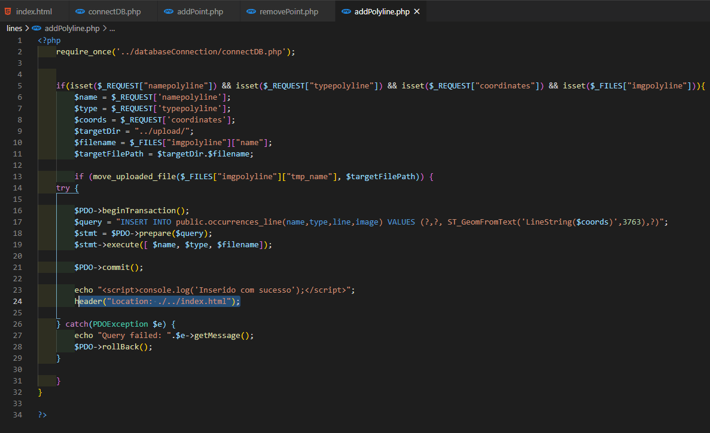

In the case of the polygon, a "ST_GeomFromText ('Polygon(coords), 3763)" is made in the query, which constructs a PostGIS ST_Geometry object from the OGC Well-Known text representation. These points will be in the SRS of Portugal (3763).

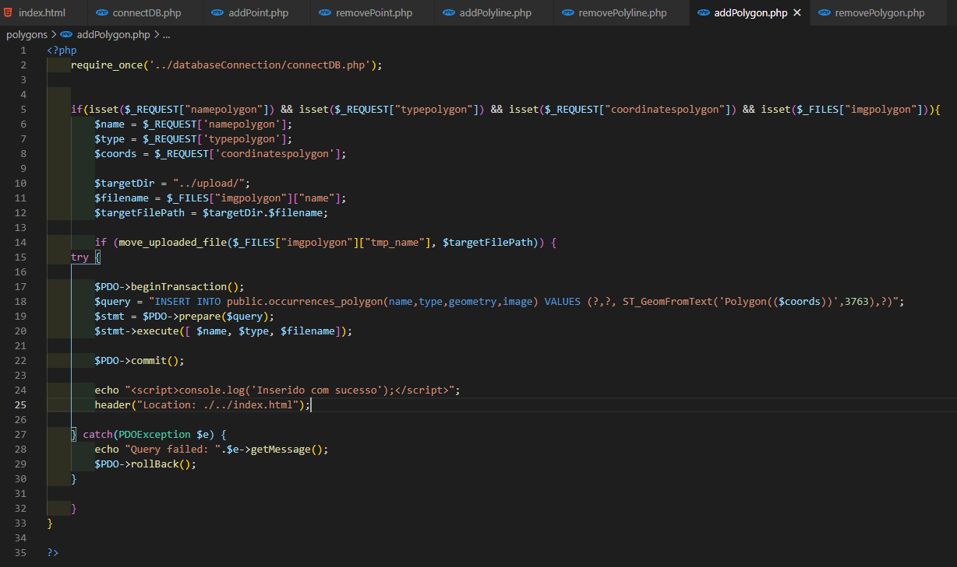

**Remove data from database**

To remove markers, polylines or polygons the structures was the same. We just need send the id and run the delete query.

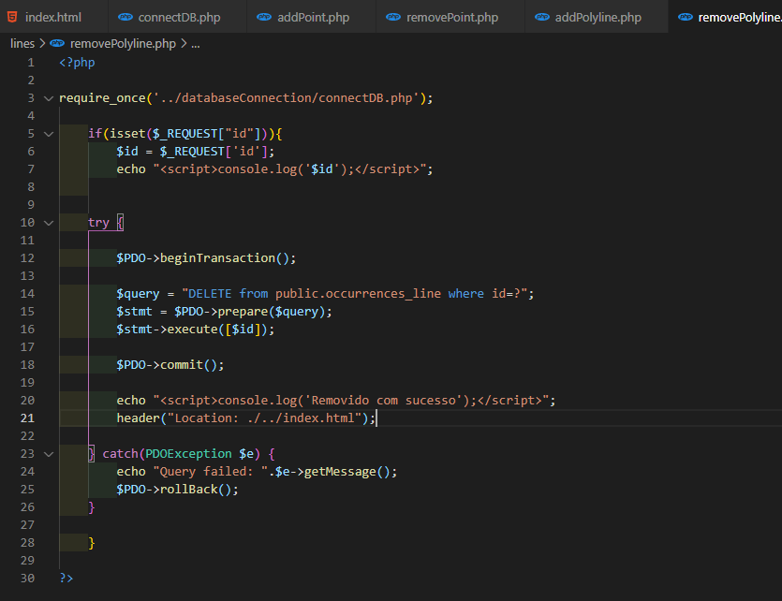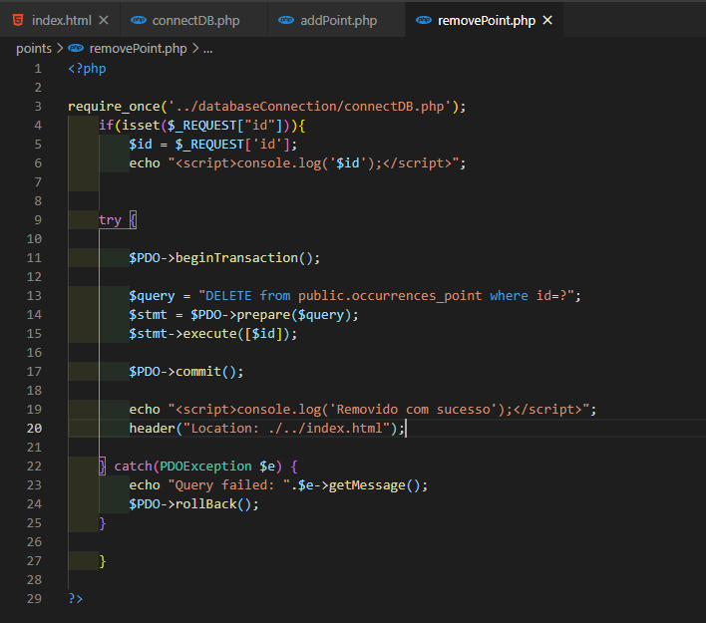

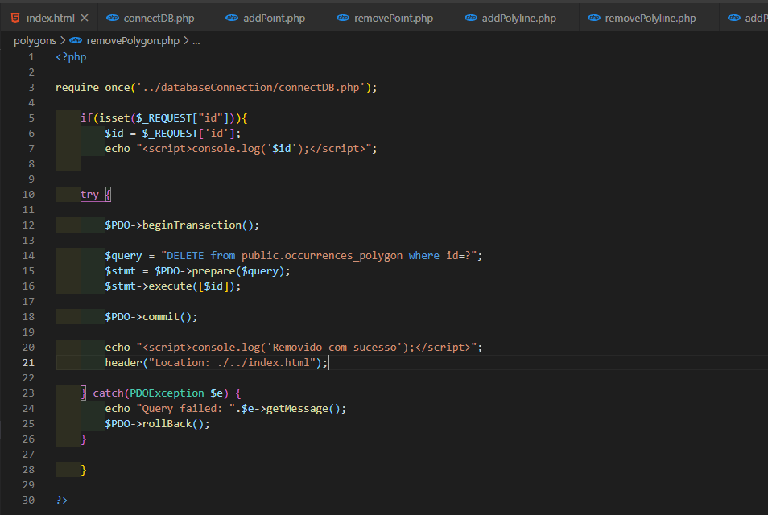

On database the inserted markers, polylines and polygons were inserted

# 5. Conclusions

By integrating multiple platforms and tools, for example by integrating a PostgreSQL database with geospacial data features into Lealeft and an open-source map provider alongisde Geoserver, it was possible to build a functioning WebSIG that not only is able to call different layers and build them on top of the existing map but also is able to provide features for users to use.

These features, like inserting, deleting and visualyzing data, make the WebSIG a powerful information provider tool to be provided to everyone.

# 6. Bibliography and Web References

## 6.1 Web References:

■ Leaflet: <https://leafletjs.com/examples/geojson/>

■OpenLayers:<https://openlayers.org/>  
■Geoserver:<http://geoserver.org/>  
■ PostgreSQL: <https://www.postgresql.org/>

■ Quantum GIS: <https://www.qgis.org/en/site/>

■ dados.gov: <https://dados.gov.pt/pt/>